VOLCANOGENIC MASSIVE SULPHIDE DEPOSITS
ALAN G. GALLEY1, MARK D. HANNINGTON2, AND IAN R. JONASSON1
- Geological Survey of Canada, 601 Booth Street, Ottawa, Ontario K1A 0E8
- Department of Earth Sciences, University of Ottawa, Marion Hall, 140 Louis Pasteur,Ottawa, Ontario K1N 6N5 Corresponding author’s email: agalley@nrcan.gc.ca

Abstract
Volcanogenic massive sulphide (VMS) deposits, also known as volcanic-associated, volcanic-hosted, and volcano- sedimentary-hosted massive sulphide deposits, are major sources of Zn, Cu, Pb, Ag, and Au, and significant sources for Co, Sn, Se, Mn, Cd, In, Bi, Te, Ga, and Ge. They typically occur as lenses of polymetallic massive sulphide that form at or near the seafloor in submarine volcanic environments, and are classified according to base metal content, gold con- tent, or host-rock lithology. There are close to 350 known VMS deposits in Canada and over 800 known worldwide. Historically, they account for 27% of Canada’s Cu production, 49% of its Zn, 20% of its Pb, 40% of its Ag, and 3% of its Au. They are discovered in submarine volcanic terranes that range in age from 3.4 Ga to actively forming deposits in modern seafloor environments. The most common feature among all types of VMS deposits is that they are formed in extensional tectonic settings, including both oceanic seafloor spreading and arc environments. Most ancient VMS deposits that are still preserved in the geological record formed mainly in oceanic and continental nascent-arc, rifted- arc, and back-arc settings. Primitive bimodal mafic volcanic-dominated oceanic rifted arc and bimodal felsic-dominated siliciclastic continental back-arc terranes contain some of the world’s most economically important VMS districts. Most, but not all, significant VMS mining districts are defined by deposit clusters formed within rifts or calderas. Their clustering is further attributed to a common heat source that triggers large-scale subseafloor fluid convection systems. These subvolcanic intrusions may also supply metals to the VMS hydrothermal systems through magmatic devolatiliza- tion. As a result of large-scale fluid flow, VMS mining districts are commonly characterized by extensive semi-con- formable zones of hydrothermal alteration that intensifies into zones of discordant alteration in the immediate footwall and hanging wall of individual deposits. VMS camps can be further characterized by the presence of thin, but areally extensive, units of ferruginous chemical sediment formed from exhalation of fluids and distribution of hydrothermal particulates.

Résumé
Les gîtes de sulfures massifs volcanogènes (SMV) sont connus sous diverses appellations parmi lesquelles on peut mentionner les gîtes de sulfures massifs associés à des roches volcaniques, encaissés dans des roches volcaniques ou logés dans des assemblages volcano-sédimentaires. Ils constituent des sources considérables de Zn, Cu, Pb, Ag et Au, ainsi que des sources importantes de Co, Sn, Se, Mn, Cd, In, Bi, Te, Ga et Ge. Ils consistent généralement en lentilles de sulfures massifs polymétalliques formées dans des milieux volcaniques sous-marins, au sein ou à proximité du fond océanique, et sont classés d’après leur contenu en métaux communs ou en or ou selon la lithologie des roches encais- santes. Près de 350 gîtes SMV ont été découverts au Canada et plus de 800, de par le monde. Dans l’histoire de la pro- duction minière du Canada, 27 % du cuivre, 49 % du zinc, 20 % du plomb, 40 % de l’argent et 3 % de l’or ont été extraits de gisements SMV. On trouve de tels gîtes aussi bien dans des terrains volcaniques sous-marins datant de 3,4 Ga que dans les fonds océaniques actuels où de nouveaux gîtes sont en cours de formation. La caractéristique la plus commune à tous les gîtes de SMV tient à leur formation dans des milieux tectoniques de distension, parmi lesquels on peut mentionner les fonds océaniques en expansion et les arcs. La plupart des anciens gîtes SMV conservés dans les archives géologiques se sont formés dans des milieux océaniques et continentaux d’arc naissant, d’arc de divergence et d’arrière-arc. Quelques-uns des districts à gisements SMV les plus importants dans le monde sur le plan économique se trouvent dans des terrains océaniques primitifs d’arc de divergence caractérisés par un volcanisme bimodal à domi- nante mafique, de même que dans des terrains continentaux d’arrière arc caractérisés par un volcanisme bimodal à dom- inante felsique et la présence de matériaux silicoclastiques. La plupart des principaux districts miniers à gisements SMV consistent en amas de gisements formés dans des rifts ou des caldeiras. Leur regroupement est attribuable à l’existence d’une source de chaleur commune qui donne naissance à de vastes réseaux de convection de fluides sous le plancher océanique. Les intrusions subvolcaniques qui produisent cette chaleur peuvent aussi fournir des métaux aux réseaux hydrothermaux des gîtes SMV par le biais d’un dégagement magmatique de matières volatiles. En raison de l’écoule- ment de fluides sur une grande étendue, les districts miniers à gisements SMV se caractérisent souvent par la présence de vastes zones semi-concordantes d’altération hydrothermale, qui gagnent en intensité pour devenir des zones d’altéra- tion discordantes, dans l’éponte inférieure et l’éponte supérieure immédiates des gisements. Ces districts se distinguent aussi par la présence d’unités minces mais étendues de sédiments chimiques ferrugineux qui résultent de l’exhalaison et de la diffusion de particules hydrothermales.

Definition
Volcanogenic massive sulphide (VMS) deposits are also known as volcanic-associated, volcanic-hosted, and vol- cano-sedimentary-hosted massive sulphide deposits. They typically occur as lenses of polymetallic massive sulphide that form at or near the seafloor in submarine volcanic envi- ronments. They form from metal-enriched fluids associated
with seafloor hydrothermal convection. Their immediate host rocks can be either volcanic or sedimentary. VMS deposits are major sources of Zn, Cu, Pb, Ag, and Au, and significant sources for Co, Sn, Se, Mn, Cd, In, Bi, Te, Ga, and Ge. Some also contain significant amounts of As, Sb, and Hg. Historically, they account for 27% of Canada’s Cu production, 49% of its Zn, 20% of its Pb, 40% of its Ag, and

Galley, A.G., Hannington, M.D., and Jonasson, I.R., 2007, Volcanogenic massive sulphide deposits, in Goodfellow, W.D., ed., Mineral Deposits of Canada: A Synthesis of Major Deposit-Types, District Metallogeny, the Evolution of Geological Provinces, and Exploration Methods: Geological Association of Canada, Mineral Deposits Division, Special Publication No. 5, p. 141-161.

3% of its Au. Because of their poly- metallic content, VMS deposits continue to be one of the most desirable deposit types for security against fluctuating prices of differ- ent metals.
VMS deposits form at, or near, the seafloor through the focused discharge of hot, metal-rich hydrothermal fluids. For this rea- son, VMS deposits are classified under the general heading of “exhalative” deposits, which includes sedimentary exhalative (SEDEX) and sedimentary nickel deposits (Eckstrand et al., 1995). Most VMS deposits have two com- ponents (Fig. 1). There is typically a mound-shaped to tabular, stratabound body composed princi- pally of massive (>40%) sulphide, quartz and subordinate phyllosili- cates, and iron oxide minerals and altered silicate wall-rock. These stratabound bodies are typically underlain by discordant to semi- concordant stockwork veins and

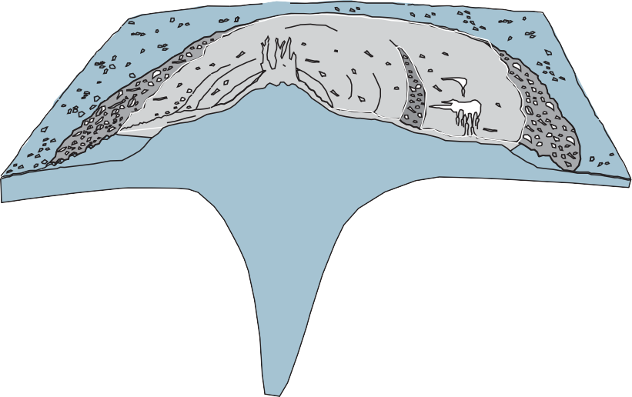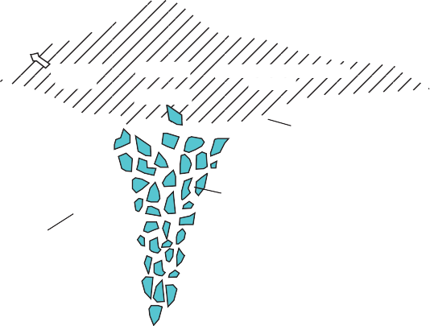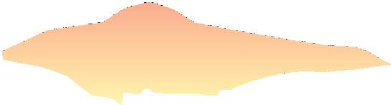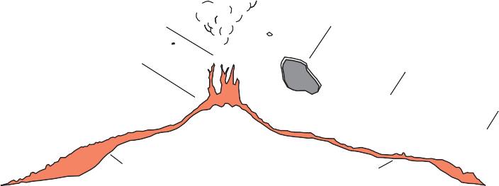
100 M
BLACK SMOKER COMPLEX
COLLAPSED AREA
ANHYDRITE CONE
WHITE SMOKERS
DEBRIS APRON &
METALLIFEROUS SEDIMENT
SULFIDE TALUS

ANHYDRITE
SEALED PYRITE Zn-RICH MARGINAL ZONE FACIES
QUARTZ

GRADATIONAL CONTACT
SILICIFIED, PYRITIC STOCKWORK
APPROX. LIMIT OF DEMAGNETIZED ZONE
CHLORITIZED ± HEMATIZED BASALT
ALTERATION PIPE
F_{IGURE} 1. Schematic diagram of the modern TAG sulphide deposit on the Mid-Atlantic Ridge. This repre- sents a classic cross-section of a VMS deposit, with concordant semi-massive to massive sulphide lens under- lain by a discordant stockwork vein system and associated alteration halo, or “pipe”. From Hannington et al. (1998).

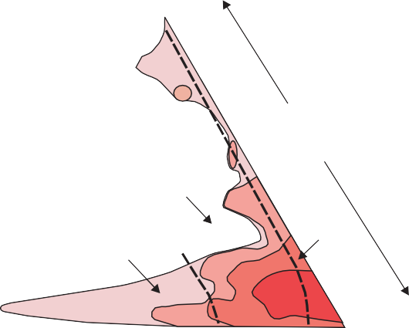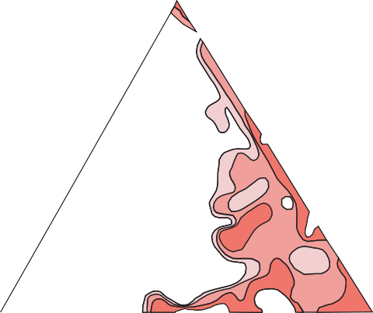Cu

disseminated sulphides. The stock-
work vein systems, or “pipes”, are enveloped in distinctive alteration halos, which may extend into the hanging-wall strata above the VMS deposit.
VMS deposits are grouped according to base metal content, gold content, and host-rock lithol- ogy (Figs. 2, 3, 4). The base metal classification used by Franklin et al. (1981) and refined by Large (1992) and Franklin et al. (2005) is
World VMS
(Modified from Franklin, 1996)
Cu

Zn-Pb-Cu

Pb-Zn

Zn-Cu

103 tonnes per 1% area
1-100

100-1000
1000-10 000

>10 000

perhaps the most common. VMS deposits are divided into Cu-Zn, Zn-Cu, and Zn-Pb-Cu groups according to their contained ratios of these three metals (Fig. 2). The Cu-Zn and Zn-Cu categories for Canadian deposits were further refined by Morton and Franklin
Pb Zn Cu
SEDEX deposits VMS deposits Cu

Canadian VMS

(1987) into Noranda and Mattabi types, respectively, by including the character of their host rocks (mafic vs. felsic, effusive vs. vol- caniclastic) and characteristic alter- ation mineral assemblages (chlo-
Zn-Pb-Cu

Pb-Zn

Zn-Cu

rite-sericite dominated vs. sericite-
quartz ± carbonate-rich). The Zn- Pb-Cu category was added by Large (1992) in order to more fully represent the VMS deposits of Australia (Fig. 2). Poulsen and Hannington (1995) created a sim-
Pb Zn
SEDEX deposits VMS deposits

F_{IGURE} 2. Base metal classification scheme of worldwide and Canadian VMS deposits as defined by Franklin et al. (1981) and modified by Large (1992) to include the Zn-Pb-Cu class. The preponderance of Cu-Zn and Zn-Cu VMS deposits in Canada is due to the abundance of Precambrian primitive oceanic arc settings. Worldwide, there is a larger proportion of felsic-hosted, more Pb-rich continental rift and continent margin arc settings.

ple bimodal definition of “normal” versus “Au-rich” VMS deposits (Fig. 3). This originally was intended to identify deposits that are transitional between VMS and epithermal deposits (e.g. Sillitoe et al., 1996) (Fig. 4). Further research has indicated a more complex spectrum of conditions for the generation of Au-rich VMS related to water depth, oxidation state, the temperature of the metal-depositing fluids, and possible magmatic contributions (e.g. Hannington et al., 1999a). In the classification of Poulsen and Hannington (1995) Au-rich VMS deposits are arbitrarily defined as those in which the abundance of Au in ppm is numerically greater than the combined base metals (Zn+Cu+Pb in wt.%, Fig. 3). A third classification system that is gaining acceptance is a five-fold grouping first suggested by Barrie and Hannington (1999), and later modified by Franklin et al. (2005). This

Gold (ppm)

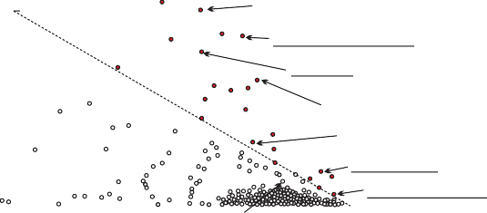AURIFEROUS

MT MORGAN BOUSQUET NO 2
HORNE
BOLIDEN RAMBLER CONS
LA RONDE
ESKAY CREEK

system classifies VMS deposits by their host lithologies (Fig. 4), which includes all strata within a host succession
Cu+Zn+Pb (%)
FLIN FLON Silver (ppm)

defining a distinctive time-stratigraphic event (Franklin et
al., 2005). These five different groups are bimodal-mafic, mafic-backarc, pelitic-mafic, bimodal-felsic, and felsic-sili- ciclastic. To this is added a sixth group of hybrid bimodal felsic, which represent a cross between VMS and shallow- water epithermal mineralization (Fig. 4). These lithologic groupings generally correlate with different submarine tec- tonic settings. There order here reflects a change from the most primitive VMS environments, represented by ophiolite settings, through oceanic rifted arc, evolved rifted arcs, con- tinental back-arc to sedimented back-arc.

Geographical Distribution
There are close to 850 known VMS deposits worldwide with geological reserves of over 200,000 t. They are located in submarine volcanic terranes that range in age from the 3.4 Ga Archean Pilbara Block, Australia, to actively forming deposits in modern seafloor spreading and oceanic arc ter- ranes (Fig. 5, Table 1). VMS-epithermal hybrids are also forming today in volcanically active shallow submarine (Manus Basin) and lacustrine environments. VMS deposits are recognized on every major continent except Antarctica, although Zn-Pb-Cu deposits are forming in the Bransfield Strait adjacent to the Antarctic Peninsula (Peterson et al., 2004). Cu and Au have been produced from Tertiary-age deposits hosted in ophiolites around the eastern Mediterranean and Oman for over 5000 years. Prior to 2002, VMS deposits are estimated to have supplied over 5 billion tonnes of sulphide ore (Franklin and Hannington, 2002). This includes at least 22% of the world’s Zn production, 6% of the world’s Cu, 9.7% of the world’s Pb, 8.7% of its Ag, and 2.2% of its Au (Singer, 1995).
Over 350 deposits and major VMS occurrences contain- ing geological reserves of more than 200,000 tonnes are known in Canada, of which only 13 are producing mines as of 2006 (Fig. 6, Table 2). Of these, Louvicourt, Bouchard- Hébert, Selbaie, and Konuto have been closed. VMS deposits are known to occur in every province and territory except Alberta and Prince Edward Island. The largest num- ber of deposits is in Quebec (33%), followed in descending order by Manitoba (15%), Newfoundland (12%), British Columbia (10%), Ontario (9%), and New Brunswick (9%). The deposits in New Brunswick have had the highest aggre-
F_{IGURE} 3. Classification of VMS deposits based on their relative base metal
(Cu+Zn+Pb) versus precious metal (Au, Ag) contents. Some of Canada’s better known auriferous deposits (underlined) are compared to international examples. Despite having produced 170 t of Au, the Flin Flon deposit is not considered an auriferous VMS deposit under this classification. Modified from Hannington et al. (1999c).

gate metal value (Cu+Zn+Pb), followed by Quebec and then Ontario (Fig. 7).

Grade and Tonnage
The over 800 VMS deposits worldwide range in size from 200,000 tonnes to supergiant deposits containing more than 150 million tonnes (Franklin et al., 2005) (Table 3). Among the largest is Rio Tino, Spain’s portion of the Iberian Pyrite Belt (IPB), with contained ore in excess of 1.535 Bt. The richest supergiant produced to date is Neves Corvo on the Portuguese side of the IPB, with ore in excess of 270 Mt, with 8.8 Mt of contained metal. At the average metal prices to date for 2006 (Cu=$1.75/lb, Zn=$1.25/lb, Ag=$6.00/oz), this orebody was originally worth in the order of 26 billion dollars (US). Other large districts are the Urals and Rudny Altai of Russia and Kazakhstan with over 70 Mt of contained metals each (Fig. 5). Canada has two supergiant VMS deposits (Windy Craggy and Brunswick No. 12) and two giant VMS deposits (Kidd Creek, and Horne), which are defined as being in the upper 1% of the world’s VMS deposits with respect to total original reserves (Fig. 10A). In Canada, the largest VMS mining district is Bathurst, New Brunswick, which contained over 320 Mt of geological resource of massive sulphide containing 30 Mt of combined Zn, Cu, and Pb (Figs. 6, 10A). The 128 Mt Brunswick No. 12 deposit alone contained 16.4 Mt of metal (Table 2). This is followed by the 138.7 Mt Kidd Creek deposit containing
  - Mt of metal. The largest known Canadian VMS deposit
is the 297 Mt Windy Craggy deposit, but it contains only 4.1 Mt of Cu, Co, and Au. The 50 Mt Horne deposit contains 2.2 Mt of Zn+Cu+Pb, along with over 330 t of Au, making it also a world-class gold deposit (Fig. 10B). The 98 Mt LaRonde VMS deposit contains 258 Mt of gold, and because of its high Au/base metal ratio (Au ppm/Zn+Cu+Pb% = 1.9) it is classified by its owner as a gold deposit rather than a VMS deposit.
Determining the mean and median metal concentrations for Canadian VMS deposits is difficult due to missing or

100 m BACK-ARC MAFIC  Canadian grade and tonnage  Average 1.3 Mt Median 2.3Mt  3.2% Cu  1.9% Zn  Chlorite-sericite alteration 0.0% Pb  + jasper infilling  15 g/t Ag  Pillowed mafic 2.5 g/t Au  flows  Banded jasper- Sphalerite-chalcoppyrite Pyrite-quartz in situ breccia chert-sulphide -rich margin  Pyrite-quartz breccia Quartz-pyrite stockwork  Massive pyrite Chlorite-pyrite stockwork | BIMODAL-MAFIC  Canadian grade and tonnage  Average 6.3 Mt  Median 113.9 Mt  1.7% Cu  Lobe-hyaloclastite 5.1% Zn  rhyolite 0.6% Pb  45 g/t Ag  Pillowed mafic 1.4 g/t Au  flows 200 m  Sericite-chlorite Massive magnetite- Sulphidic tuffite/exhalite pyrrhotite-chalcopyrite Massive pyrite-sphalerite  Quartz-chlorite Pyrrhotite-pyrite- -chalcopyrite  Chlorite-sulphide chalcopyrite stockwork Massive pyrite-  pyrrhotite-chalcopyrite
BIMODAL-FELSIC  Flows or volcaniclastic strata 100 m  Canadian grade and tonnage  Average 5.5 Mt  Median 14.2 Mt  1.3% Cu  6.1% Zn  1.8% Pb  123 g/t Ag  Felsic flow complex 2.2 g/t Au  Sericite-quartz Detrital Pyrite-sphalerite-galena Barite (Au) tetrahedrite-Ag-Au  Chlorite-sericite Pyrite-sphalerite-galena Carbonate/  gypsum  Quartz-chlorite Pyrite-sphalerite-chalcopyrite  Chalcopyrite- Chalcopyrite-pyrrhotite-pyrite  pyrite veins | Shale/argillite HYBRID  BIMODAL-FELSIC  Felsic 200 m  clastic  Felsic lava  dome  Quartz-sericie- Realgar-cinnabar-stibnite Infilling and Al silicate Arsenopyrite-stibnite- replacement  (advanced argillic) tetrahedrite-Pb sulphosalts  Sericite-quartz-pyrite Quartz-pyrite-arsenopyrite-  (argillic) sphalerite-galena-tetrahedrite veins
FELSIC- SILICICLASTIC  Canadian grade and tonnage  Average 9.2 Mt  Median 64.4 Mt  0.98% Cu  4.7% Zn  2.0% Pb  53 g/t Ag  0.93 g/t Au  Iron formation facies Carbonaceous shale Chlorite-pyrrhotite-pyrite Hematite Massive fine-grained and -chalcopyrte-(Au) Magnetite layered pyrite Siliceous stockwork  Layered pyrite-sphalerite-  Carbonate galena-Ag-Au (transitional ore) 500 m  Manganese-iron Massive pyrrhotite-pyrite-  chalcopyrite-(Au) | PELITIC-  Laminated argillite MAFIC  and shale Canadian grade and tonnage  Average 34.3 Mt  Median 148 Mt  1.6% Cu  Basalt sill/flow 2.6% Zn  0.36% Pb  29 g/t Ag  Laminated argillite <0.9 g/t Au  and shale 200 m  Pyrrhotite-pyrite-magnetite Chert-carbonate-sulphide transition zone  Pyrrhotite-pyrite-chalcopyrite zone Pyrite-sphalerite zone  Pyrrhotite-chalcopyrite-pyrite- Massive pyrite zone sphalerite stockwork zone

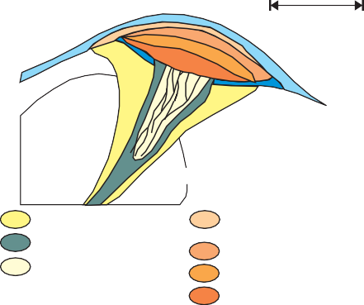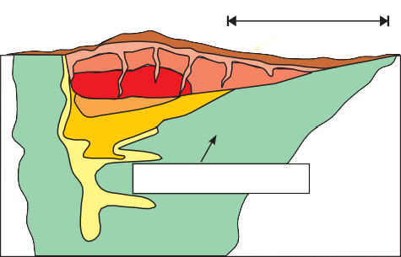incomplete data for a large number of deposits. Pb grades are known for 34% of Canadian deposits, whereas 55% have known Au grades and 75% have known Ag grades. From the available production data, the mean and median (in brackets) size and grades for past and present producing Canadian deposits are 7 306 521 t grading 4.88% (4.12) Zn, 1.62%
F_{IGURE} 4. Graphic representation of the lithological classifications modified from Barrie and Hannington (1999) by Franklin et al. (2005), with the addition of the hybrid bimodal felsic as a VMS-epithermal subtype of bimodal-felsic. Average and median sizes for each type for representative Canadian deposits shown, along with average grade.
Massive
Argillite-shale
Alkaline basalt
Felsic epiclastic

Felsic volcaniclastic and epiclastic

Basement sediments

(0.70) Cu, 1.639% (1.00) Pb, 63 g/t (37) Ag, and 1.65 g/t
(0.88) Au. Figure 9B shows the more meaningful breakdown of tonnage and grade for each of the five Canadian VMS types as defined by host lithology. Bimodal mafic deposits account for the greatest number and, therefore, the largest aggregate tonnage of the five deposit types, with both silici- clastic types accounting for the largest average tonnage. The
mafic-siliciclastic deposit types have the highest average tonnage, with the number highly skewed by Windy Craggy. As expected, the three deposit types dominated by mafic vol- canic and volcaniclastic rocks have the highest Cu grades, whereas the two felsic-dominated deposit types contain the highest Pb and Ag contents. The bimodal felsic deposit group contains the highest average gold. Mafic-ultramafic- dominated systems can also contain Se, Co, and Ni. The presence of immature sediments (i.e. black shale) within the footwall stratigraphy can also influence hydrothermal fluid composition, as is postulated for he Se-rich Wolverine and KZK deposits in the Finlayson Lake camp (Bradshaw et al., 2003). Possible contributions from devolatilizing subvol-

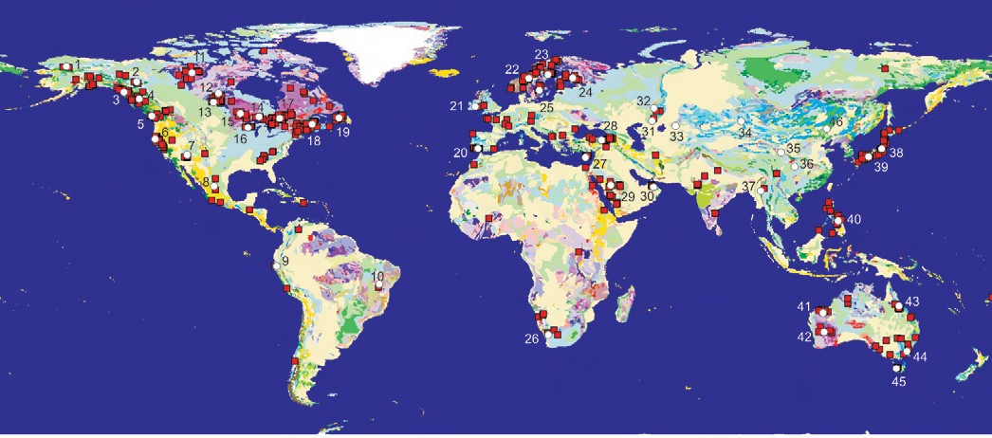

canic intrusions may also account for anomalous Se, Sn, In, Bi, Te, and possibly Au and Sb contents (Hannington et al., 1999c; Yang and Scott, 2003; Dubé et al., 2004).
F_{IGURE} 5. Geographical distribution of ancient VMS deposits, with major districts highlighted with respect to known aggregate geological reserves (see Table 1). Modified from Sinclair et al. (1999) and Franklin et al. (2005).

Geological Attributes
Tectonic Environment
The most common feature among all types of VMS deposits is that they are formed in extensional tectonic set- tings, including both oceanic seafloor spreading and arc environments (Fig. 11). Modern seafloor VMS deposits are recognized in both oceanic spreading ridge and arc environ- ments (Herzig and Hannington, 1995), but deposits that are
preserved in the geological record formed mainly in oceanic and continental nascent-arc, rifted arc, and back-arc settings (Franklin et al. 1998; Allen et al., 2002) (Fig. 11). This is because during subduction-driven tectonic activity much of the ancient ocean-floor is subducted, leaving only a few ophiolite suites as remnant obducted ocean-floor. Examples of these include the Ordovician Bay of Islands ophiolite in Newfoundland and the Late Triassic Cache Creek terrane in British Columbia (Bédard and Hébert, 1996; Nelson and Mihalynuk, 2004).
Nascent, or early arc rifting, results from the initial foundering of older thickened oceanic crust, commonly

T_{ABLE} 1. Major world volcanogenic massive sulphide deposits and districts.
No.* | Deposit/District, Country | Tonnage (Mt) | No.* | Deposit/District, Country | Tonnage (Mt)
1 | Brooks Range, Alaska | 35 | 23 | Skellefte, Sweden | 70
2 | Finlayson Lake, Yukon | 20 | 24 | Outokumpu-Pyhasalmi, Finland | 90
3 | Windy Craggy, BC & Green's Creek, Alaska | 300 | 25 | Bergslagen-Orijarvi, Sweden & Finland | 110
4 | Northern Cordillera, British Columbia | 100 | 26 | Preiska, South Africa | 45
5 | Myra Falls, British Columbia | 35 | 27 | Troodos, Cyprus | 35
6 | Shasta, California | 35 | 28 | Black Sea, Turkey | 200
7 | Jerome, Arizona | 40 | 29 | Saudi Arabia | 70
8 | Central Mexico | 120 | 30 | Semail, Oman | 30
9 | Tambo Grande, Peru | 200 | 31 | Southern Urals, Russia / Kazahkstan | 400
10 | Amazonian craton, Brazil | 35 | 32 | Central Urals, Russia | 100
11 | Slave Province, Northwest Territories, Nunavut | 30 | 33 | Rudny Altai, Kazahkstan / Russia | 400
12 | Ruttan, Manitoba | 85 | 34 | Altai Shan, Mongolia | 40
13 | Flin Flon-Snow Lake, Manitoba | 150 | 35 | North Qilian, China | 100
14 | Geco, Manitouwadge, Ontario | 60 | 36 | Sanjiang, China | 50
15 | Sturgeon Lake, Ontario | 35 | 37 | Bawdwin-Laochang, Burma / | 40
16 | Ladysmith-Rhinelander, Wisconsin/Michigan | 80 | 38 | Hokuroku, Japan | 80
17 | Abitibi, Ontario-Quebec | 600 | 39 | Besshi, Japan | 230
18 | Bathurst, New Brunswick | 495 | 40 | Phillipines arc | 65
19 | Dunnage Zone, Newfoundland | 75 | 41-42 | Pilbara, Yilgarn Western Australia | 75
20 | Iberian Pyrite Belt, Spain & Portugal | 1575 | 43 | Central Queensland, Australia | 80
21 | Avoca, Ireland | 37 | 44 | Lachlan Fold Belt, Australia | 100
22 | Trondhjeim, Norway | 100 | 45 | Mt. Read, Tasmania | 200
 |  |  | 46 | Sino-Korean Platform | 40
* numbers refer to Figure 5; tonnage is approximate

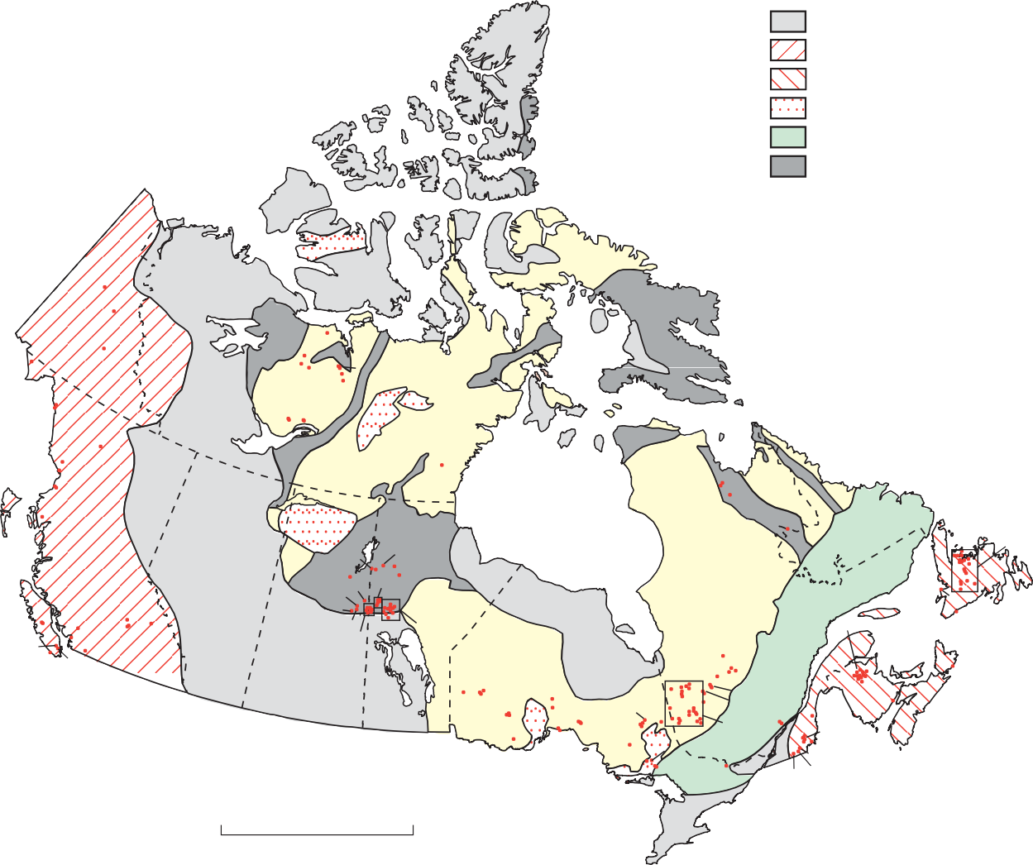F_{IGURE} 6. Distribution of VMS deposits in Canada by geologic province. Numbers correspond to deposits listed in the national VMS database (Appendix 1).
D, E
Phanerozoic cover rocks Mesozoic orogen
Paleozoic orogen
Proterozoic cover rocks
Middle Proterozoic orogen Early Proterozoic orogen Archean craton
262

261
263
258
233,235
234
227
230
224-226
223
222
259
260
231,
232 228,229

249
257
256 169
251-255
58
59 57
250
50
1-27
211
221
194,195
176
202 170
218 217 196-201
Fig. 2F
29
240
243
247,248
245
246
242 237-239 236
241
244
220
219
203-210,
212 -216
171-175,
177-193
32-49, 51-56
28
75
Fig. 2
74 73
76
168 165
166, 167
72
30
157
158
151-154 141
144
160-164
159
146-148
155, 156
150
149
77-79
83 80, 82
70, 71
84-140
31
145
81
60
62-65
61
66
142, 143
68, 69 67
0
km
1000

T_{ABLE} 2. Canadian volanogenic massive sulphide deposits presently in production (2005).
Deposit | Location | (1) Mt | Cu | Zn | Pb | Ag | Au | Age
 |  |  | wt.% | wt.% | wt.% | g/t | g/t
Brunswick No. 12 | Bathurst, New Bruswick | 229.8 | 0.46 | 7.66 | 3.01 | 91 | 0.46 | Ordovician
Kidd Creek | Abitibi, Ontario | 149.3  (181 mined + all resources) | 2.89 | 6.36 | 0.22 | 92 | 0.05 | Archean
LaRonde (incl. LaRonde II) | Abitibi, Quebec | 88.1 | 0.32 | 1.71 |  | 40.9 | 5.07 | Archean
Selbaie | Abitibi, Quebec | 47.3 | 0.98 | 1.98 |  | 20 | 0.9 | Archean
Myra Falls Gp.,Buttle Lake | Wrangellia, British Columbia | 29.3 | 1.83 | 6.25 | 0.55 | 49 | 2.01 | Devonian
Trout Lake | Trans-Hudson Orogen, Manitoba | 20 | 1.83 | 5.59 |  | 17.4 | 1.73 | Paleoproterozic
Louvicourt | Abitibi, Quebec | 19.3 | 3.1 | 1.71 |  | 28.7 | 0.83 | Archean
Triple 7 | Trans-Hudson Orogen, Manitoba | 14.5 | 3.32 | 5.78 |  | 37.7 | 2.71 | Paleoproterozic
Bouchard-Hébert | Abitibi, Quebec | 10.2 | 2.11 | 4.79 |  | 15 | 1.4 | Archean
Callinan | Trans-Hudson Orogen, Manitoba | 9.16 | 1.41 | 3.59 |  | 23.5 | 2.08 | Paleoproterozic
Duck Pond* | Central Volcanic Belt, | 5.2 | 3.24 | 5.97 | 1.1 | 61.5 | 0.88 | Ordovician
Perseverence Group * | Abitibi , Quebec | 5.1 | 1.24 | 15.82 |  | 29.4 | 0.38 | Archean
Eskay Creek | Stikine, British Columbia | 4 | 0.33 | 5.4 | 2.2 | 998 | 26.4 | Jurassic
Bell Allard | Abitibi, Quebec | 3.2 | 1.5 | 13.77 |  | 43.5 | 0.76 | Archean
Chisel North | Trans-Hudson Orogen, Manitoba | 2.8 | 0.15 | 9.36 | 0.4 | 22 | 0.4 | Paleoproterozic
Konuto | Trans-Hudson Orogen, | 1.28 | 5.27 | 1.44 |  | 10.6 | 2.09 | Paleoproterozoic
* In preproduction ( 2006)
    - Includes production and estimated reserves where applicable.

35
7
6
12
42
46
35
33
115
1
6
31
TOTAL TONNAGE
in billion tonnes
2.60
1.44
1.24 1.34
0.18
2.5
30 2.0
1.5
25 1.0
Total metals (Mt)
0.5
20
AVERAGE TONNAGE 23.7
in million tonnes

11.0
2.8
5.1
5.2
25
15 20
10 15
10
5 5

0
NUMBER OF DEPOSITS
284
255

113
62
97
300

200

100

2
1.5
1
0.5
5
4
3
2
1

1.5
1
0.5

80
60
40
20

3
2
1
A
MAFIC
Cu (wt.%)
Zn (wt.%)
Pb (wt.%)
Ag (g/t)

Au (g/t)
(Ophiolite type)
e.g. Troodos, Cyprus

BIMODAL-MAFIC
e.g. Preiska,
South Africa &
San Nicolas, Mexico

MAFIC- SILICICLASTIC
e.g. Besshi, Japan

BIMODAL-FELSIC
e.g. Mount Lyell,
Tasmania

BIMODAL- SILICICLASTIC
e.g. Rio Tinto, Spain

Province

F_{IGURE} 7. Histogram of the total tonnage of base metals from known VMS deposits per province; also shown are the number of deposits. The aggre- gate tonnage was calculated by total metals represent divided by geological reserves (proven, possible, and probable; non 43-101 compliant).
along transform fault sutures (Bloomer et al., 1995). These early suprasubduction terranes are most commonly observed in the ancient rock record at the base of oceanic arc assem- blages in which VMS deposits are spatially associated with isolated extrusive rhyolite complexes near the top of thick basalt and basaltic andesite successions. The best Canadian example of these bimodal mafic-dominated caldera settings is the Paleoproterozoic host succession to the Anderson, Stall, and Rod VMS deposits in the Snow Lake camp, Manitoba (Bailes and Galley, 1999). The komatiite-basalt- rhyolite setting for the Archean Kidd Creek deposit is inter-

2.5
2.0
TOTAL TONNAGE
in billion tonnes
1.49
0.03
0.34 0.35 0.36
1.5
1.0
0.5

25
34.3
AVERAGE
TONNAGE in million tonnes

8.73
7.5
4.7
1.2
20
15
10
5

300
NUMBER OF DEPOSITS

197

73
24
9
40

200

100

2
1.5
1
0.5
5
4
3
2
1

1.5
1
0.5

80
60
40
20

2
1
B
MAFIC
Cu (wt.%)

Zn (wt.%)

Pb (wt.%)

Ag (g/t)
109
Au (g/t)
(Ophiolite type)
e.g. Tilt Cove, Newfoundland
BIMODAL-MAFIC
e.g. Noranda, Quebec
& Kidd Creek, Ontario

MAFIC- SILICICLASTIC
e.g. Windy Craggy, British Columbia
BIMODAL-FELSIC
e.g. Myra Falls,
British Columbia

BIMODAL- SILICICLASTIC
e.g. Bathurst No. 12, New Brunswick

preted to be an early primitive arc setting possibly linked to an underlying mantle plume (Wyman et al., 1999), or a rare example of a non-arc VMS setting associated with partial lithospheric melting above a mantle plume (cf. Iceland).
In the idealized evolutionary stages of arc terrane forma- tion, extension of the principal arc assemblage is another common period of VMS formation (Fig. 11). This results in

Number of Deposits
0 20 40 60 80 100 120 140
Windy Craggy
Kidd Creek, Brunswick 12

Flin Flon, Caribou, LaRonde, Horne, Geco
Average ancient sulfide deposit
Typical modern seafloor sulfide deposit
500
200
100
Size in Million Metric Tonnes
50
20
10
5
2
1.0
0.5
0.2
F_{IGURE} 8. Global (proven, possible, and probable; non 43-101 compliant) size distribution for VMS deposits, with deposits over 50 Mt considered “very large” (Table 1), those over 100 Mt considered “giant”, and those over 150 Mt defined as “supergiant”. Atlantis II Deep, Red Sea, is consid- ered the largest modern example of a seafloor massive sulphide deposit. Best known examples of Canadian very large, giant, and supergiant deposits are shown. Modified from Hannington et al. (1995).
F_{IGURE} 9. Statistics for VMS deposits grouped by lithologic class (Barrie
and Hannington, 1999): (A) worldwide deposits; (B) Canadian deposits.

the formation of calderas in which bimodal mafic extrusive successions predominate. This is perhaps the most common arc environment for VMS formation in oceanic arc settings. Bimodal mafic-dominated VMS-hosting calderas include the Archean Noranda and the Paleoproterozoic Flin Flon mining camps (Gibson and Watkinson, 1990; Syme and Bailes, 1993). Rifting of continental margin arcs, in contrast, results in the development of more volcaniclastic-rich bimodal felsic extensional settings. Examples include the Sturgeon Lake camp in the Archean Wabigoon terrane of Ontario (Morton et al., 1990; Whalen et al., 2004) and the Devonian Buttle Lake VMS camp in the Wrangellia Terrane of British Columbia (Barrett and Sherlock, 1996a). Outside Canada, the Paleoproterozoic Skellefte mining district in Sweden (Allen et al., 1996a) and the Cambrian Mount Read VMS district in Tasmania (Corbett, 1992) are other examples of rifted continental margin arc settings. Continued exten- sion in both oceanic and continental margin arc settings results in the development of back-arc basins. In oceanic arc settings, mature back-arc ophiolites also can host VMS deposits. Canadian examples include the Paleoproterozoic Birch-Flexar-Coronation camp on the Saskatchewan side of the Flin Flon mining district (Wyman et al., 1999) and Betts Cove, Newfoundland (Swinden et al., 1988; Bédard et al., 1998). Well known examples outside Canada include the Tethyan ophiolites in Cyprus (Troodos), Oman (Semail), and Turkey (Ergani) (Galley and Koski, 1999, and references therein).

T_{ABLE} 3. Examples of large-tonnage volcanogenic massive sulphide deposits of the World (Canadian deposits in red).
NAME | COUNTRY | Orogen | Mtonnes Ore (Geol.) | CU  % | PB  % | ZN  % | AU  (g/t) | AG  (g/t) | Orebody Age  (est. Ma)
SUPERGIANT  Rio Tinto (Stockwork) | Spain | Hercynian | 1200.00 | 0.15 |  | 0.15 |  | 7.00 | 320
Rio Tinto (Massive) | Spain | Hercynian | 335.00 | 0.39 | 0.12 | 0.34 | 0.36 | 22.00 | 320
Kholodnina | Russia | Baikal-Vitim | 300.00 | 0.04 | 0.79 | 5.2 |  |  | 750
Windy Craggy (Cu,Co) | Canada | N.Cordilleran | 297.40 | 1.38 |  | 0.25 | 0.22 | 3.83 | 220
Neves Corvo Group | Portugal | Hercynian | 270.00 | 1.59 | 0.15 | 1.41 |  | 9.87 | 320
Gai East | Russia | Uralides (Hercynian) | 269.00 | 1.2 |  | 0.7 | 1.10 | 7.70 | 395
Aljustrel Group (total) | Portugal | Hercynian | 250.00 | 1.2 | 1.2 | 3.2 | 1.00 | 38.00 | 320
Brunswick #12 | Canada | Appalachian | 229.80 | 0.46 | 3.01 | 7.66 | 0.46 | 91.00 | 465
Gai | Russia | Uralides (Hercynian) | 205.00 | 1.4 | 0.06 | 0.5 | 1.10 | 7.90 | 395
La Zarza | Spain | Hercynian | 164.00 | 1.2 | 1.1 | 2.5 | 1.80 | 47.00 | 320
Ducktown | USA | Grenvillean? (Oecee) | 163.34 | 1 |  | 0.9 | 0.30 | 3.00 | 1000
GIANT  Kidd Creek | Canada | Abitibi (Kenoran) | 147.88 | 2.31 | 0.22 | 6.18 | 0.01 | 87.00 | 2714
Horne - No. 5 Zone | Canada | Abitibi (Kenoran) | 144.00 | 1 |  | 0.9 | 1.40 |  | 2698
Ozernoe | Russia | Baikal-Vitim | 130.00 | 0.01 | 1.2 | 6.2 |  |  | 500
Ridder-Sokol | Kazakhstan | Altaides (Hercynian) | 125.00 | 0.3 | 2 | 4 | 2.50 | 10.00 | 400
Zyryanov | Kazakhstan | Altaides (Hercynian) | 125.00 | 0.4 | 2.7 | 4.5 | 0.13 | 20.00 | 395
Gacun | China | Yidun, Indosinian (Tethyan) | 124.00 | 0.72 | 4.62 | 6.66 | 0.46 | 157.00 | 200
Masa Valverde | Spain | Hercynian | 120.00 | 0.5 | 0.6 | 1.3 | 0.80 | 38.00 | 320
Sibai | Russia | Uralides (Hercynian) | 115.00 | 1 | 0.04 | 1.56 | 0.60 | 16.00 | 392
Tharsis | Spain | Hercynian | 110.00 | 0.5 | 0.6 | 2.7 | 0.70 | 22.00 | 320
Yubileinoe | Russia | Uralides (Hercynian) | 107.00 | 1.9 | 0.1 | 1.2 | 2.50 | 16.00 | 392
Uchaly | Russia | Uralides (Hercynian) | 106.00 | 1.1 |  | 3.8 | 1.10 | 15.50 | 392
Madneuli | Georgia | Caucasian (Tethyan) | 102.60 | 1.29 |  | 1.8 | 0.73 | 4.31 | 70
VERY LARGE  Mount Lyell | Australia | Tasman | 98.57 | 1.17 | 0.01 | 0.04 | 0.39 | 7.20 | 495
Rouez | France | Caledonian | 90.74 | 0.6 |  | 1.5 | 1.50 | 21.00 | 600
Aznalcollar | Spain | Hercynian | 90.00 | 0.51 | 0.85 | 1.8 | 0.48 | 37.00 | 320
LaRonde (incl.LaRonde-II) | Canada | Abitibi (Kenoran) | 88.00 | 0.3 |  | 1.7 | 5.07 | 40.90 | 2710
Skorpion | Namibia | Gariep | 85.00 |  | 0.71 | 8.05 |  |  | 752
Podolsk | Russia | Uralides (Hercynian) | 84.10 | 2.01 | 0.13 | 1.3 | 1.49 | 27.60 | 392
Murgul | Turkey | Pontides (Tethyan) | 83.14 | 0.76 | 0.05 | 0.03 | 0.05 | 3.70 | 175
Ruttan | Canada | Trans-Hudson | 82.80 | 1.37 | 0.08 | 1.63 | 0.49 | 13.11 | 1900
Tambo Grande 3 | Peru | S.Cordilleran | 82.00 | 1 | 0.3 | 1.4 | 0.80 | 25.00 | 104
San Nicolas | Mexico | C.Cordilleran | 79.90 | 1.34 |  | 2.27 | 0.53 | 30.00 | 136
Pyhasalmi | Finland | Svecokarelian | 75.70 | 0.9 | 0.06 | 1.9 | 0.20 | 14.00 | 1921
Sotiel | Spain | Hercynian | 75.20 | 0.56 | 1.34 | 3.16 | 0.21 | 24.00 | 320
Los Frailes | Spain | Hercynian | 70.00 | 0.34 | 2.25 | 3.92 |  | 62.00 | 320
Heath Steele | Canada | Appalachian | 69.90 | 0.98 | 0.89 | 2.69 | 0.54 | 47.00 | 465
Ulaan | Mongolia | Kazakh-Mongol(Hercyn.) | 68.00 |  | 1.2 | 2 | 0.21 | 53.00 | 380
Caribou | Canada | Appalachian | 64.69 | 0.51 | 1.6 | 4.29 | 1.89 | 51.00 | 465
Crandon | USA | Trans-Hudson | 63.50 | 1 |  | 6.5 |  |  | 1870
Flin Flon | Canada | Trans-Hudson | 62.93 | 2.2 |  | 4.1 | 2.85 | 43.20 | 1875
Zincgruvan( +Knalla) | Sweden | Svecokarelian | 60.00 |  | 3.2 | 10.4 |  | 69.00 | 1890
Tishin | Kazakhstan | Altaides (Hercynian) | 60.00 | 0.5 | 0.9 | 5.3 | 0.90 | 15.00 | 395
Geco | Canada | West.Superior (Kenoran) | 58.40 | 1.86 | 0.15 | 3.45 |  | 50.06 | 2720
Tambo Grande 1 | Peru | S.Cordilleran | 56.20 | 1.6 | 0.3 | 1 | 0.50 | 26.00 | 104
Deerni (Cu-Co) | China | Indosinian (Tethyan) | 54.00 | 1.23 |  | 1.57 | 0.42 | 4.73 | 260
Horne-H&G Orebodies | Canada | Abitibi (Kenoran) | 53.70 | 2.2 |  |  | 6.10 | 13.00 | 2700
Mount Morgan | Australia | Tasman | 50.00 | 0.7 | 0.05 | 0.1 | 4.70 | 0.60 | 385
Outokumpu(Cu,Zn,Co) | Finland | Svecokarelian | 50.00 | 3.3 | 0.005 | 1.07 | 0.07 | 9.00 | 1970
Artem'yev | Kazakhstan | Altaides (Hercynian) | 50.00 | 1.4 | 1.6 | 2.2 | 1.20 | 143.00 | 375
Lousal | Portugal | Hercynian | 50.00 | 0.7 | 0.8 | 1.4 | 0.70 | 21.00 | 300
LARGE  Britannia | Canada | N.Cordilleran | 49.31 | 1.08 | 0.033 | 0.26 | 0.34 | 4.03 | 150
Novo-Leninogorsk | Kazakhstan | Altaides (Hercynian) | 48.00 | 0.16 | 1.43 | 4.04 | 1.54 | 32.80 | 395
Preiska | South Africa | Namaqua | 47.00 | 1.7 |  | 3.8 | 0.00 |  | 1300
Anyox-Hidden Creek | Canada | N.Cordilleran | 45.95 | 1.37 |  |  | 0.17 | 9.92 | 195
Hanaoka Mine (total) | Japan | Japan arcs(Tethyan) | 43.50 | 1.2 | 1.5 | 4.7 | 0.40 | 68.00 | 15
Aguas Tenidas | Spain | Hercynian | 41.00 | 1.3 | 0.91 | 3.1 | 0.50 | 37.00 | 320
Hongtoushan | China | Sino-Korean Platform | 40.00 | 1.75 |  | 2.4 | 0.77 | 32.40 | 3000
Maleev | Kazakhstan | Altaides (Hercynian) | 40.00 | 2.3 | 1.3 | 7.5 | 0.75 | 75.00 | 390
Orlovskoye | Kazakhstan | Altaides (Hercynian) | 40.00 | 2.4 | 0.5 | 2.1 | 0.80 | 47.00 | 392
Ashele (#1) | China | Altayshan (Hercynides) | 34.00 | 2.51 |  | 2.98 | 0.57 | 104.03 | 375
Xiaotieshan | China | Tarim-NorthQilian (Caled.) | 34.00 | 1.26 | 3.39 | 5.33 | 2.28 | 126.20 | 440
Arctic (Brooks Range,Ak) | USA | N.Cordilleran | 32.93 | 4 | 0.8 | 5.5 | 0.70 | 55.00 | 365
Rosebery | Australia | Tasman | 32.70 | 0.58 | 4.4 | 14.5 | 2.70 | 145.00 | 495
Liwu | China | Yidun, Indosinian (Tethyan) | 31.00 | 2.5 |  | 0.62 |  |  | 430
Belousov | Kazakhstan | Altaides (Hercynian) | 30.00 | 2.6 | 2.4 | 9.2 | 2.00 | 119.00 | 395
Lokken ( Hoydal) | Norway | Caledonian | 30.00 | 2.3 | 0.02 | 1.8 | 0.29 | 19.00 | 450
Jerome- United Verde | USA | Yavapai | 30.00 | 4.8 |  | 0.2 | 1.37 | 49.70 | 1800
Bald Mountain | USA | Appalachian | 29.98 | 1.03 | <0.05 | 1.12 | 0.51 | 14.40 | 430
Besshi | Japan | Japan arcs(Tethyan) | 29.95 | 2.6 |  | 0.3 | 0.70 | 21.00 | 210
Selbaie | Canada | Abitibi (Kenoran) | 29.90 | 1.21 |  | 1.91 | 0.63 | 37.02 | 2730
Myra Falls Group | Canada | N.Cordilleran | 29.32 | 1.83 | 0.55 | 6.25 | 2.00 | 49.00 | 365
Garpenberg (+Lappberget) | Sweden | Svecokarelian | 29.00 | 0.3 | 3.3 | 5.3 | 0.65 | 98.00 | 1890
Bisha | Eritrea | Pan African | 28.60 | 1.52 |  | 4.63 | 1.68 | 46.80 | 850
Vihanti | Finland | Svecokarelian | 28.10 | 0.48 | 0.36 | 5.12 | 0.49 | 25.00 | 1910
Falun | Sweden | Svecokarelian | 28.10 | 3 | 1.5 | 4 | 3.00 | 20.00 | 1875
Safyanovka | Russia | Uralides (Hercynian) | 27.50 | 3.04 |  | 1.4 | 1.32 | 25.00 | 392
McIlvenna Bay | Canada | Trans-Hudson | 27.23 | 0.9 | 0.1 | 3.27 | 0.34 | 16.43 | 1900
Mattagami Lake | Canada | Abitibi (Kenoran) | 25.60 | 0.42 |  | 5.1 | 0.30 | 21.60 | 2725
Las Cruces ( primary) | Spain | Hercynian | 25.20 | 1.25 | 1.69 | 3.63 | 0.38 | 38.00 | 320
Granduc | Canada | N.Cordilleran | 25.06 | 1.79 | 0.021 | 0.1 | 0.17 | 10.63 | 190
Korbalikhinsk | Russia | Altaides (Hercynian) | 25.00 | 1.46 | 2.01 | 9.81 |  |  | 375
Greens Creek | USA | N.Cordilleran | 25.00 | 0.32 | 5.1 | 13.9 | 5.61 | 706.00 | 220
* Modified from Franklin et al., 2005

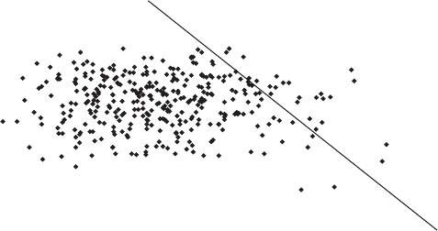100.0
Brunswick #12
Kidd Creek Ruttan
Caribou
Windy
Geco
A
Flin Flon

10.0
Cu+Zn+Pb (%)

1.0

0.1

0.0
0.01 0.1 1.0 10
Tonnage (Mt)

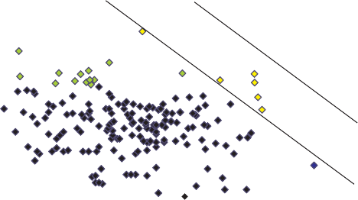100.0
Bousquet 2 Horne
LaRonde-Penna Flin Flon
Caribou
B
Eskay Creek

10.0

Craggy

100 1,000
formation of multiple mineral deposit types, including epithermal and VMS deposits. A good example of this is the Lower Jurassic Hazelton Group in British Columbia, which hosts the Eskay Creek Au-rich VMS deposit (Barrett and Sherlock, 1996b; Nelson and Mihalynuk, 2004). When these strike-slip fault systems propagate into a continental margin setting, such as in the modern day Guaymas Basin, Gulf of California, the strike-slip basins begin to infill with terrige- nous sediment. They can host mafic siliciclastic-hosted VMS deposits, such as the Triassic Windy Craggy and Green’s Creek deposits in British Columbia and Alaska, respectively (Peter and Scott, 1999). These are known as Besshi-type deposits from the type locality in the fore-deep accretionary wedge outboard of the Miocene Japanese islands. Other mafic siliciclastic-hosted VMS deposits occur along modern sedimented seafloor spreading systems such as Middle Valley, on the Juan de Fuca Ridge off the British Columbia coast (Goodfellow et al., 1999).

1.0
Au (g/tonne)
Failed, or Incipient Rift A
0.1

0.0
0.01 0.1 1.0 10 100
Tonnage (Mt)

1,000
B

Ocean Island
F_{IGURE} 10. Distribution of Canadian VMS deposits with respect to (A) aggregate base metal grade versus tonnes and (B) contained Au versus tonnes; most auriferous Au deposits contain >4 g/t Au (green diamonds). Those containing over 1000 tonnes of Au (yellow diamonds) include both auriferous VMS deposits and those with moderate Au grades but large ton- nages. Giant and supergiant VMS deposits are identified by name. From National VMS database (Appendix 1).

Ocean Spreading Centre

Nascent Arc

Rifted Arc

Back-Arc Spreading Centre

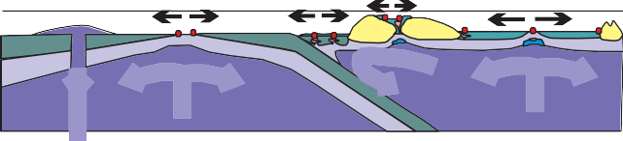

Continental back-arc settings contain some of the world’s most economically important VMS districts. These environ- ments are dominated by bimodal siliciclastic rocks ± iron formation and include the Ordovician Bathurst camp of New Brunswick (van Staal et al., 2003) and Finlayson Lake (Piercey et al., 2001). Examples outside Canada include the Archean Golden Grove camp in Western Australia (Sharpe

Mature Oceanic Arc
Back-Arc

Continental Arc

C
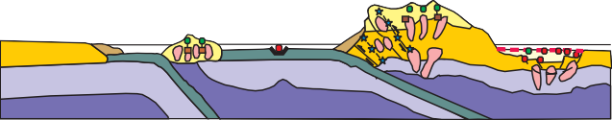Back-Arc Extension

and Gemmell, 2002), the Paleoproterozoic Bergslagen dis- trict of Sweden (Allen et al., 1996b), the Cambro-Ordovician Mount Windsor district of Queensland (Doyle and McPhie, 2000), the Devono-Mississippian Iberian Pyrite Belt (Carvalho et al., 1999), and parts of the Devonian Southern
Ocean crust Lithosphere Asthenosphere

VMS deposits
Arc assemblage Continental crust Siliciclastic strata

Epithermal Au Orogenic Au
□ Fe-formation Granitoid
Mafic-ultramafic intrusion
Porphyry Cu-Au (+ skarns)

Urals VMS districts of Russia and Kazakhstan (Herrington et al., 2002; Franklin et al., 2005).
Other extensional environments may form in post-accre- tion and/or successor arc settings. Crustal thickening of an accreted ocean-floor-arc assemblage can result in modifica- tion of the angle of descent of the subducting slab, cessation of subduction along a section of plate boundary, or a change in the direction of approach of the colliding plates (Ziegler, 1992; Hamilton, 1995). This process results in the generation of strike-slip basins in the older arc assemblages. Magmatism associated with these successor arc basins may be associated with mineralized porphyry systems (Richards, 2003), and the basins may be infilled with both subaqueous and subaerial bimodal volcanic rocks. This can result in the
F_{IGURE} 11. There are three principal tectonic environments in which VMS
deposits form, each representing a stage in the formation of the Earth’s crust. (A) Early Earth evolution was dominated by mantle plume activity, during which numerous incipient rift events formed basins characterized by early ocean crust in the form of primitive basalts and/or komatiites, fol- lowed by siliciclastic infill and associated Fe-formation and mafic-ultra- mafic sills. In the Phanerozoic, similar types of incipient rifts formed dur- ing transpressional, back-arc rifting (Windy Craggy). (B) The formation of ocean basins was associated with the development of ocean spreading cen- ters along which mafic-dominated VMS deposits formed. The development of subduction zones resulted in oceanic arc formation with associated extensional domains in which bimodal mafic, bimodal felsic, and mafic- dominated VMS deposits formed. (C) The formation of mature arc and ocean-continent subduction fronts resulted in successor arc and continental volcanic arc assemblages that host most of the felsic-dominated and bimodal siliciclastic deposits. Thin black arrows represent direction of extension and thick, pale arrows represent mantle movement. Modified from Groves et al., 1998

Flin Flon (80 Mt)

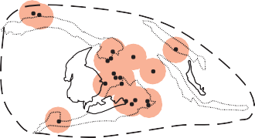
Noranda (100 Mt)

5 km

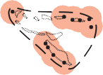
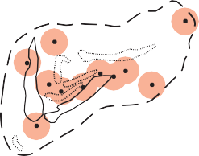Matagami (34 Mt)

Snow Lake (40 Mt)
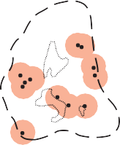
Hokuroku District (90 Mt)
zontal, resulting in the formation of a stratified, district-scale semi-conformable alteration zone controlled in extent by the strike length of the underlying intrusion (Spooner and Fyfe, 1973; Munha and Kerrich, 1980; Lagerblad and Gorbatchev; 1985; Gibson and Watkinson, 1990; Galley, 1993; Alt, 1995; Brauhart et al., 1998; Bailes and Galley, 1999) (Fig. 14). The distribution of the resulting alteration mineral assemblages mimics that of regional metamorphic facies (Spooner and Fyfe, 1973; Alt, 1995; Hannington et al., 2003) (Fig. 15). Hydrothermal fluid reaction zones immediately overlying the intrusions can be altered to amphibolite-facies assem- blages, including Fe-Ca-rich amphibole, clinozoisite, Ca- plagioclase, and magnetite (Figs. 15, 16A,B,C). Above this are Na-Ca-rich greenschist-facies assemblages characterized by albite, quartz, chlorite, actinolite, and epidote. Closer to

District-Scale Environments
F_{IGURE} 12. A same-scale comparison of selected VMS districts. A 5 km diameter circle around each deposit shows the hypothetical area of influ- ence of proximal-scale alteration about each deposit, all encircled by a dashed line defining the proposed extent of a regional-scale alteration sys- tem for each camp based on the presence of known felsic volcanic and syn- volcanic formations/intrusions (thin black lines). The Noranda example corresponds closely to the observed alteration. Modified from Sangster (1980).
Most, but not all VMS deposits, occur in clusters that define major mining camps. Sangster (1980) used the distri- bution of VMS deposits within well known mining districts in Canada to indicate that there was a first-order regional control on their distribution (Fig. 12). In general, the deposit clusters are restricted to either linear rifts or calderas. These features are generated by regional thinning of the basement, decompression melting of the underlying mantle, and gener- ation of mafic magmas (Fig. 13). In ocean spreading-ridge settings, these magmas rise to within a few thousand metres of the seafloor to form elongate gabbroic sills that parallel the seafloor-spreading axes (Stinton and Detrick, 1992). Where pre-existing ocean-floor or arc lithosphere is present, these mafic magmas, at temperatures of 1000 to 1400°C, may underplate the crust, producing intermediate to felsic partial melts and bimodal mafic intrusive/extrusive assem- blages. The associated gabbro-diorite-tonalite-trondhjemite intrusive complexes may rise to within 2 to 3 km of the seafloor (Galley, 2003, and references therein). Where exten- sion is taking place in thicker (20-30 km) crust, such as in a continental back-arc setting, magmas may form mid-crustal intrusions. These melts may not intrude into their comag- matic volcanic assemblages but may remain in the underly- ing basement rocks. These different scenarios result in mul- tiple forms of district-scale alteration and deposit character- istics for a VMS district.
The presence of either mafic or composite high-level sub- volcanic intrusions within a rift or caldera setting will drive a subseafloor hydrothermal-fluid convection system (Galley, 1993; Alt, 1995) (Fig. 14). Connate seawater in the porous

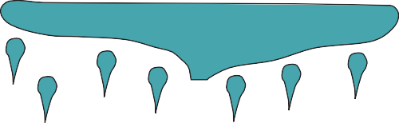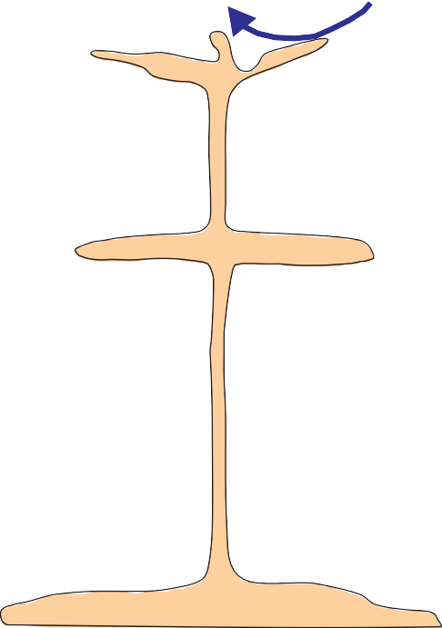Crust Mantle

2 km
5 km
Partial Melting of Crust
20 km
Mantle decompression and melting (>1300°C)
Mantle Partial Melt

Felsic melts Mafic melt

crust is first heated, causing it to become buoyant. As this heated water rises up synvolcanic fault structures, cold sea- water is drawn in above the cooling intrusion. These origi- nally cold, near neutral pH fluids are progressively heated during their downward migration, interacting with the sur- rounding rocks at progressively higher temperatures. The isotherms above cooling sill complexes are generally hori-
F_{IGURE} 13. VMS environments are characterized by tectonic extension at various scales (open arrows). Extension resulted in crustal thinning, mantle depressurization, and the generation of basaltic melts. Depending on crustal thickness and density, these mafic melts ponded at the base of the crust, resulting in partial melting and generation of granitoid melts. These anhy- drous, high-temperature melts quickly rose to a subseafloor environment (<3 km below seafloor), where their heat initiated and sustained convective hydrothermal cells that formed VMS deposits (black arrows).

A

+ Si,Fe,Mn

+ K,Mg,SO4 - Si,Ca, Na, Fe, Mn 200°C
5000 m
300°C

400°C

Deep Intrusion
B SHALLOW CONVECTION

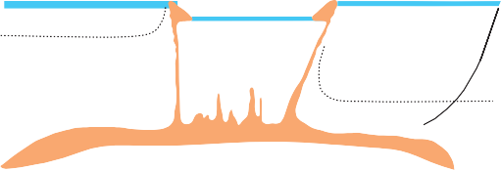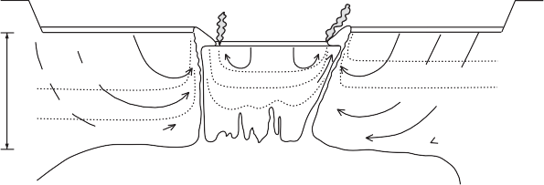Si, Fe, S
Watkinson, 1990; Brauhart et al., 1998; Galley, 2003). Faults that acted as conduits for volcanic feeder systems were the focal point for ascent of high-temperature, acidic metal- laden hydrothermal fluids that formed VMS deposits. These fault systems may have remained active through several cycles of volcanic and hydrothermal activity. This may have resulted in several periods of VMS formation at different stratigraphic levels within the rift or caldera structure.
Mafic-dominated, bimodal mafic, and bimodal felsic host rocks are dominated by effusive volcanic successions and accompanying, large-scale hypabyssal intrusions (Fig. 17). This high-temperature subseafloor environment supported high-temperature (>350°C) hydrothermal systems, from

+ K,Mg,SO4
2000 m
+ Na, Mg
+ Si, Ca
+ Ca, Si, Fe,Cu

C

Shallow Intrusion
DEEP CONVECTION

- Si,Na,Ca, Fe,Zn,Cu
200°C
300°C
400°C
which may have precipitated Cu, Cu-Zn, and Zn-Cu- (Pb) VMS deposits with variable Au and Ag contents. Areally extensive, 1 to 5 m thick, Fe-rich “exhalites” (iron forma- tions) may mark the most prospective VMS horizons (Spry et al., 2000; Peter, 2003) (Fig. 18A). These exhalite deposits consist of a combination of fine volcaniclastic material, chert, and carbonates. They formed during the immature

Zeolite

Greenschist Amphibolite
2000 m
Fe,Zn, Cu,Si

Epidosite
Mn,Si,Ni
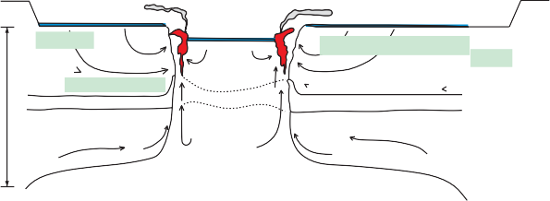Mg metasomatism Spilitization
Silicification

Recharge zone Impermeable
barrier

Reservoir zone
and/or waning stages of regional hydrothermal activity when shallowly circulating seawater stripped Fe, Si, and some base metals at <250°C and precipitated them on the seafloor through extensive, but diffuse, low-temperature hydrother- mal venting. Formation of exhalites on a basalt-dominated substrate was commonly accompanied by silicification and/or chloritization of the underlying 200 to 500 m of strata

Magmatic Component?
FORMATION OF HYDROTHERMAL CELLS
(Fig. 18B). Examples of this are observed in the Noranda,
Matagami Lake, and Snow Lake VMS camps (Kalogeropoulos and Scott, 1989; Liaghat and MacLean, 1992; Bailes and Galley, 1999). In felsic volcaniclastic-dom- inated terranes, the generation of Fe-formation exhalites was accompanied by extensive K-Mg alteration of the felsic sub- strate, as recorded in the Bergslagen district of Sweden (Lagerblad and Gorbatschev, 1985) and in the Iberian Pyrite Belt (Munha and Kerrich, 1980).
F_{IGURE} 14. The development and maturation of a generic subseafloor hydrothermal system involves three stages. (A) The relatively deep emplacement of a subvolcanic intrusion below a rift/caldera and the estab- lishment of a shallow circulating, low-temperature seawater convection system. This results in shallow subseafloor alteration and associated forma- tion of hydrothermal exhalative sediments. (B) Higher level intrusion of subvolcanic magmas and resultant generation of a deep-seated subseafloor seawater convection system in which net gains and losses of elements are dictated by subhorizontal isotherms. (C) Development of a mature, large- scale hydrothermal system in which subhorizontal isotherms control the formation of semiconformable hydrothermal alteration assemblages. The high-temperature reaction zone next to the cooling intrusion is periodically breached due to seismic activity or dyke emplacement, allowing focused upflow of metal-rich fluids to the seafloor and formation of VMS deposits. From Galley (1993).

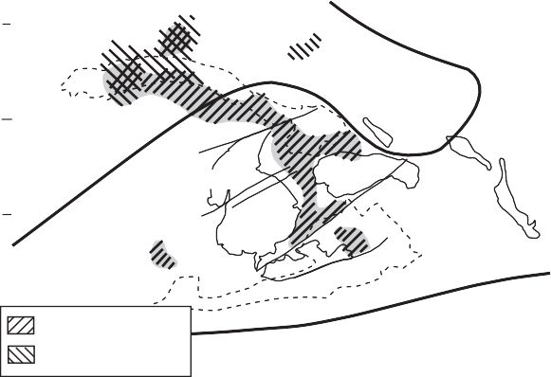5370
Chlorite-Clinozoisite- Actinolite
Prehnite- Pumpellyite
Epidote- Actinolite
Epidote- Actinolite

Clinozoisite Absent
Prehnite- pumpellyite
Prehnite- pumpellyite

the seafloor are zeolite-clay and related subgreenschist min- eral assemblages characterized by K-Mg-rich smectites, mixed-layer chlorites, and K-feldspar. In some regional hydrothermal systems, the low-temperature alteration assemblages closest to the seafloor are dominated by car- bonate species due to precipitation from shallowly circulat- ing seawater (Fig. 16D). These chemical and mineralogical changes in the ancient rock record can be further revealed by mapping shifts in bulk rock oxygen and hydrogen isotope compositions of the different zones (Green et al., 1983; Taylor and South, 1985; Aggarwal and Longstaffe, 1987;

5360

5350
Northing (UTM)

5340

610 620 630

640
Easting (UTM)

660

650

Cathles, 1993; Paradis et al., 1993). These stratified alter- ation zones can have a strike length of 5 to 50 km and a thickness of 1 to 3 km in caldera settings (Fig. 15). The size and areal morphology of the alteration system is a reflection of the size and areal morphology of the VMS deposit cluster (Fig. 12). The distribution of VMS deposits within this clus- ter depends on synvolcanic fault distribution relative to the underlying intrusions (Eastoe et al., 1987; Gibson and
F_{IGURE} 15. Comparison of regional greenschist-facies hydrothermal alter-
ation in the Noranda Volcanic Complex with previously mapped metamor- phic isograds (solid lines from Dimroth et al., 1983; Powell et al., 1993). The distribution of greenschist-facies hydrothermal alteration (shaded) sug- gests that interpreted metamorphic zonation is at least partly a product of early synvolcanic hydrothermal processes. Note that epidote and chlorite in the pre-cauldron sequence are distinct from those of the mine sequence vol- canic rocks, even though they are well within the epidote-actinolite subfa- cies and have been metamorphosed at the same pressure and temperature. Modified from Hannington et al. (2003).

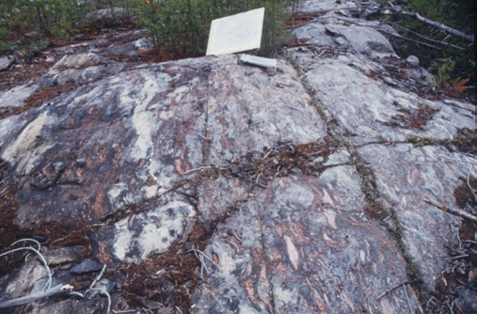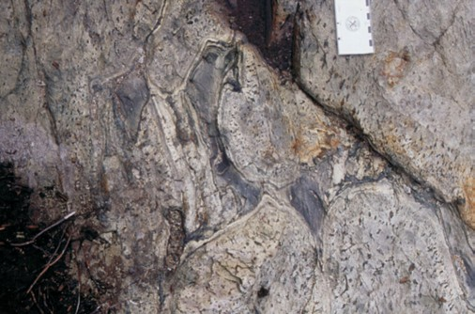
A
B
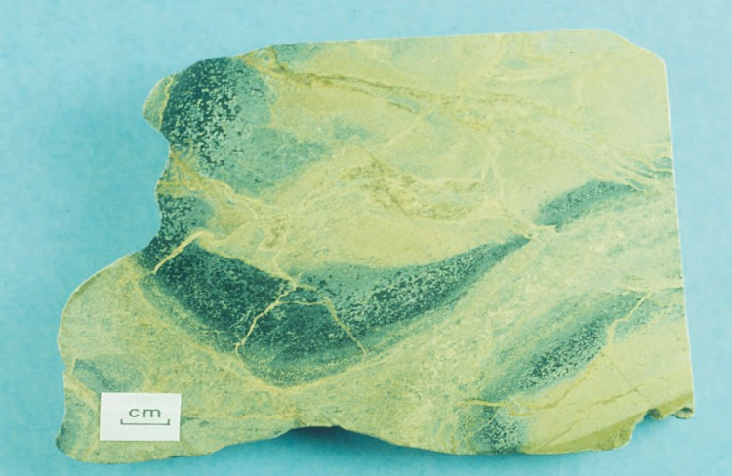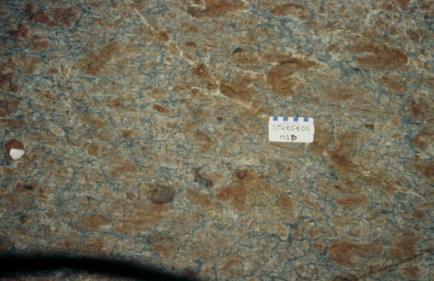
C
D

Mafic, felsic, and bimodal siliciclastic volcanic assem- blages tend to host volumetrically smaller mafic and/or fel- sic sill-dyke complexes, and generally contain Zn-Cu-Co and Zn-Pb-Cu-Ag VMS deposits, respectively. More Cu-rich deposits, such as Neves Corvo in the Iberian Pyrite Belt, may also be present in settings proximal to discrete extrusive complexes. The district-scale semiconformable hydrother- mal systems consist of low-temperature mineral assem- blages, with Mg-K smectite and K-feldspar alteration over- lain by extensive units of low-temperature Fe-Si-Mn deposits. Other types of iron formation in VMS districts are interpreted to be products of plume fallout from high-tem- perature hydrothermal venting, or collection of hypersaline brines within fault-controlled depressions on the seafloor (Peter, 2003). Iron formation horizons can extend for tens of kilometres, as in the Bathurst VMS camp in New Brunswick (Peter and Goodfellow, 1996) (Fig. 18C), the Paleoproterozoic Bergslagen district (Allen et al., 1996b), the Devono- Mississippian Iberian Pyrite Belt in Spain and Portugal (Carvalho et al., 1999), and the Mississippian Finlayson Lake camp, Yukon (Peter, 2003). Mineralogical variations within these regionally extensive iron formations, from oxide through carbonate to sulphide, are indicative of prox- imity to more focused, higher temperature hydrothermal vent complexes and also reflect stratification of the water
F_{IGURE} 16. (A) High-temperature hydrothermally altered mafic volcaniclastic turbidite (left) overlain by a strongly silicified mafic debris flow 1200 m below the Chisel-Lost-Ghost VMS horizon, Snow Lake. This is a regional-scale reaction zone overlain by a high-temperature zone of silica precipitation.
(B) Strongly silicified pillows with pipe vesicles infilled with actinolite, epidote, and magnetite, and interpillow hyaloclastite completely replaced by the same assemblage. This alteration facies directly overlies the subvolcanic Mooshla intrusion, Bousquet VMS camp, Quebec. (C) Epidosite typical of the root zones of VMS hydrothermal upflow zones in which high fluid/rock ratios have resulted in leaching of lithophile, chalcophile, and low field strength elements from the strata. (D) Chloritoid-rich zone below the Mattabi deposit, Sturgeon Lake, where Fe-rich hydrothermal fluids overprinted a previously formed carbonate- rich regional alteration zone.
column in the basin. The mineralogical variations are accompanied by changes in element ratios such as Fe, Mn, B, P, and Zn (exhalative component) versus Al and Ti (detri- tal clastic component) (Peter and Goodfellow, 1996).
Deposit-Scale Environments
VMS deposits consist of a massive to semimassive stratabound sulphide lens, and most are underlain by a sul- phide-silicate stockwork vein system (Figs. 1, 4). Within this broad framework, there is a spectrum of deposit sizes, mor- phologies, and compositions, depending on the nature of the synvolcanic faulting, footwall and host-rock lithology, water depth, size and duration of the hydrothermal system, tem- perature gradients, and degree of preservation. Individual massive sulphide lenses can be over 100 m thick, tens of metres wide, and hundreds of metres in strike length. The 135 Mt Kidd Creek deposit begins at the present erosion sur- face and extends for over 2000 m downplunge (original strike length), with the five composite orebodies over 500 m wide and individual lenses up to 100 m thick. The stratabound sulphide mound component of a VMS deposit may have a number of morphologies and variable internal structure (e.g. Fig. 1). Observations of modern seafloor hydrothermal vent complexes in effusive, flow-dominated terranes indicate that the deposits begin to form as a series of

0 km 2  N  Richard Lake  Pluton  Morgan Lake  54°45'00" |  |  | 54°52'35"  Snow McLeod Road Fault  Lake  Sneath Lake  Pluton
Synkinematic intrusions Synvolcanic intrusions |  |  | Basalt and basaltic andesite Younging direction Dacite Cu and Zn-rich VMS  Rhyolite deposits/occurrences
 |  | Volcaniclastic | C

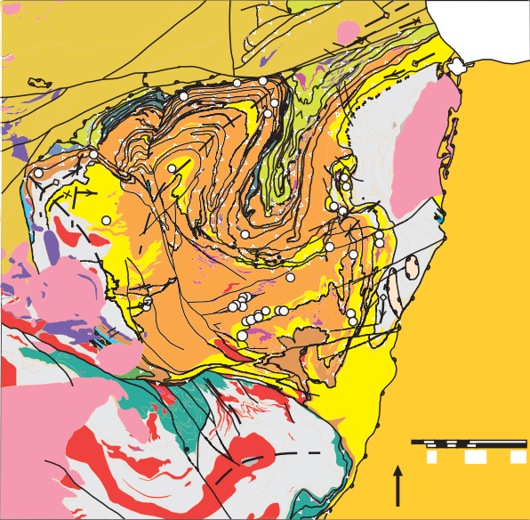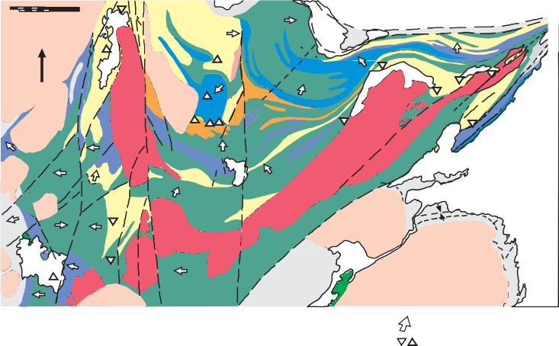F_{IGURE} 17. Examples of clusters of VMS deposits defining a mining camp. These include (A) the Archean Noranda camp, with 14 bimodal mafic-type deposits underlain by the Flavrian-Powell subvolcanic intrusion (Santaguida et al., 1998); (B) the Paleoproterozoic Flin Flon mining camp, Manitoba, with 17 VMS deposits hosted within a series of block-bounded terranes representing dif- ferent stages of oceanic arc development. For this reason, the district contains a wide variety of VMS deposit types (Syme and Bailes, 1993; Galley and Jonasson, 2003); (C) the Paleoproterozoic Snow Lake camp, Manitoba, with two subvolcanic intrusions (Sneath Lake and Richard Lake) that instigated two sepa- rate hydrothermal events and formed 8 bimodal mafic deposits (modified from Bailes and Galley, 1999); and (D) the Ordovician Bathurst mining camp with 35 deposits dominated by the bimodal siliciclastic deposit type (modified from van Staal et al., 2003).
D
VMS deposits
Upsalquitch gabbro
Late Neoproterozoic- Lower Cambrian
Tetagouche Group Sheephouse Brook Group
Fournier Group California Lake Group
Cambrian - Lower Ordovician
Miramichi Group
Gabbro Granite Blueschist nappe
47º00'
Middle Ordovician - Lower Silurian
Carboniferous
Sedimentary rocks
Upper Silurian
- Devonian
Granite Gabbro
Sedimentary and volcanic rocks
Silurian
Sedimentary and volcanic rocks
km 10
N 0
47º45'
Bathurst
66º 37'30"
65º30'
100°15'00"

sulphide-silicate-sulphate chimneys (Fig. 19A). These become structurally unstable with continued growth and col- lapse, and coalesce to form a breccia mound (Fig. 19A,C). Continued circulation of hydrothermal fluids within this breccia mound results in sealing from seawater by a silica, clay, and/or sulphate cap. Progressive deposition of metal sulphides within the mound results in the formation of a complexly textured, semimassive to massive sulphide mound. The flow of hydrothermal fluid through the mound structure commonly results in remobilization of previously
deposited metals along a chemical and temperature gradient perpendicular to the seawater interface. This process is referred to as zone refining (Eldridge et al., 1983) and results in a chalcopyrite±pyrrhotite-rich core and a sphalerite± pyrite±galena-rich outer zone (Fig. 20). In extreme cases, much of the base and precious metals can be remobilized out of the sulphide mound and carried into the seawater column by venting hydrothermal fluids and spent fluids (hot seawa- ter). Massive pyritic cores and thin, base- and precious- metal-enriched outer margins are a characteristic of VMS

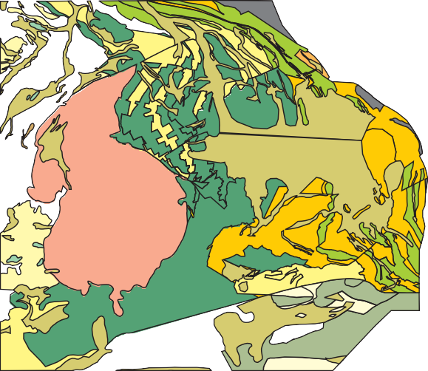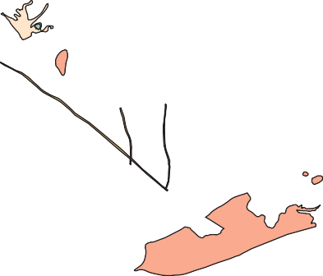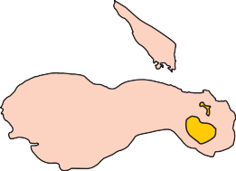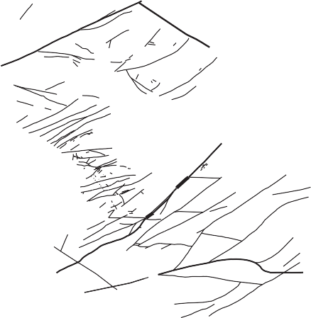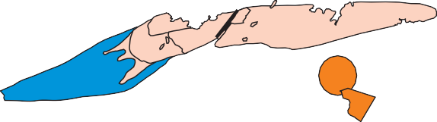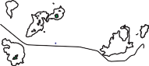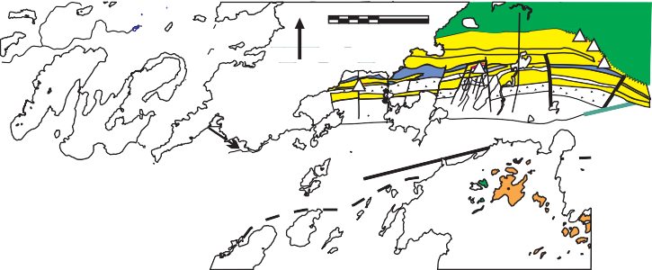
Granodiorite
Granodiorite, quartz monzonite Gabbro, diorite
Mafic volcanics Felsic volcanics
Subvolcanic Intrusions
Biedelman Bay subvolcanic intrusive complex
Pike Lake layered complex VMS deposits
B
91°00’
49°50’
5
km
0
N
Horne Volcanic Sequence A
5
km
0
Mine Sequence Andesite/Rhyolite (Cycle III)

Cycle I + II Andesite/Rhyolite
VMS Deposits/Occurrences
Cycle IV Andesite/Rhyolite (Cycle IV)
5341800
Powell
Intrusion
A
Flavrian Intrusion
Lac Dufault Granodiorite
5363060

N
B
629780
654640
99°52'30"

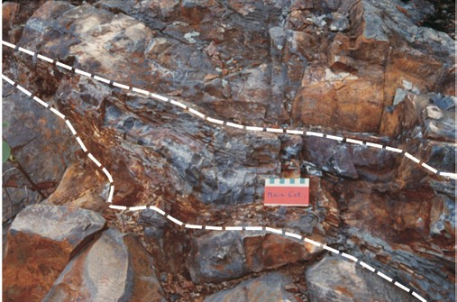
A
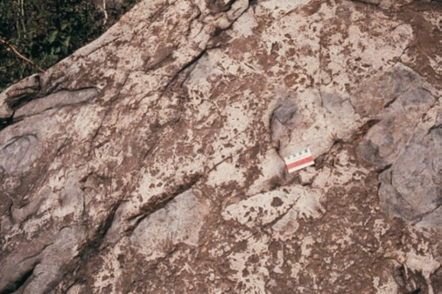
B

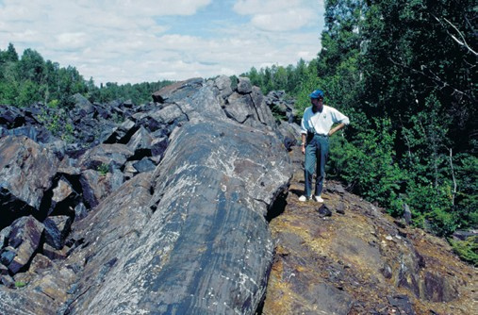
C
F_{IGURE} 18. (A) Mine contact tuff exhalite horizon (between white lines) that overlies the silicified andesites of the Waite Formation, Noranda, Quebec. (B) Silicified basaltic andesite of the Upper Amulet Formation., Noranda, Quebec, as an example of pervasive silica precipitation that occurred in mafic flows directly underlying tuffaceous exhalite units in many Precambrian VMS camps. (C) Banded magnetite-chert Fe-formation overlying the Austin Brook massive sulphide deposit, Bathurst camp (photo by J.M. Peter).
deposits that have had a protracted thermal history (e.g. Hannington et al., 1998; Petersen et al., 2000).
Although many VMS deposits have a clastic component, this is usually subordinate to the massive sulphide facies. In many cases, such as the hanging-wall orebody at Buttle Lake, British Columbia (Barrett and Sherlock, 1996a), Kidd Creek, Ontario (Hannington et al., 1999b), and Louvicourt, Quebec, these subordinate clastic facies contain a mixture of
sulphide and host-rock fragments (Fig. 19D). Interbedded sulphide and silicate-rich layers form from erosion and peri- odic collapse of a sulphide mound to form sand- to breccia- sized deposits. Examples where these clastic sulphide com- ponents are a dominant part of the deposit include Eskay Creek and Tulsequah Chief, British Columbia (Barrett and Sherlock, 1996a; Sebert and Barrett, 1996), and Buchans, Newfoundland (Walker and Barbour, 1981). In other cases, finely bedded ore lenses may result from high-temperature plume fallout of sulphide particles intermixing with hydrothermal silica, talc, and Mg-smectites, plus ambient background pelagic sedimentation (Peter, 2003, and refer- ences therein). Similar finely banded ores can also be a prod- uct of dynamic recrystallization of sulphides during regional deformation events. VMS deposits readily accommodate strain during regional deformation because of the ductile nature of massive sulphide bodies, and can therefore display much higher degrees of recrystallization and remobilization than the surrounding volcanic and sedimentary strata.
In some cases, VMS deposits do not form on the seafloor but develop as a result of shallow subseafloor replacement. This occurs when hydrothermal fluids infill primary pore space in either extrusive, autoclastic, volcaniclastic, or epi- clastic successions below an impermeable cap. At the Ansil deposit in the Archean Noranda VMS camp, a succession of laminated felsic ash flows/turbidites infilled a small fault- bounded rift on the felsic flow complex. Hydrothermal fluid seepage up the rift margins resulted in unit-by-unit replace- ment of the laminated volcaniclastic layers by pyrite, spha- lerite, and silica (Fig. 21A). This sulphide-impregnated unit was in turn replaced by massive pyrrhotite-chalcopyrite dur- ing a second stage of subseafloor replacement (Galley et al., 1996) (Fig. 21B). Some exceptionally large massive sul- phide deposits have formed within volcanic depressions infilled with autoclastic and heterolithologic debris flow and talus deposits. These include the Horne No. 5 lens (Kerr and Gibson, 1993) Kidd Creek (Hannington et al., 1999b), and several orebodies at Buttle Lake (Barrett and Sherlock, 1996a) (Fig. 21C).
Most Canadian VMS deposits are characterized by dis- cordant stockwork vein systems that commonly underlie the massive sulphide lenses, but may also be present in the immediate stratigraphic hanging-wall strata (Fig. 21D). These stockwork vein systems occur at the centre of more extensive, discordant alteration zones. They form by interac- tion between rising hydrothermal fluids, circulating seawa- ter, and subseafloor rocks. The alteration zones and attendant stockwork vein systems may extend vertically below a deposit for several hundred metres. Proximal hanging-wall alteration can manifest itself as a semi-conformable halo up to tens of metres thick (Brunswick No 12, Bathurst) or may continue above the deposit for tens to hundreds of metres as a discordant alteration zone (Ansil, Noranda). In some cases, the proximal alteration zone and attendant stockwork vein mineralization connects a series of stacked massive sulphide lenses (Amulet, Noranda; LaRonde, Bousquet) representing synchronous and/or sequential phases of ore formation dur- ing successive breaks in volcanic activity.
In plan view, proximal alteration zones may form a halo up to twice the diameter of the massive sulphide lens (Fig. 22), but with deposits such as Chisel Lake, Snow Lake

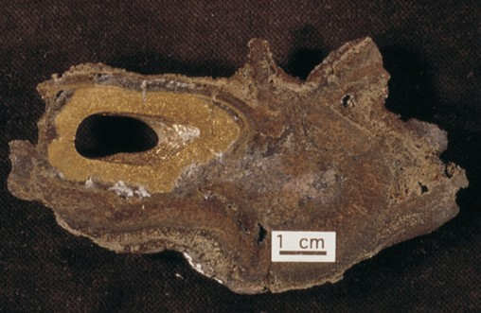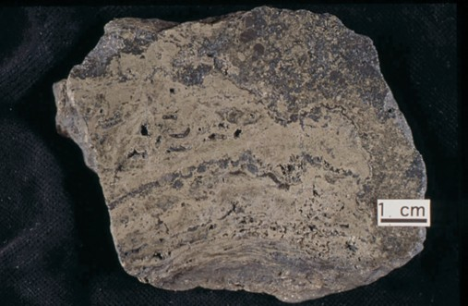
A
B
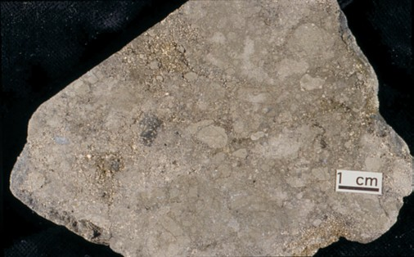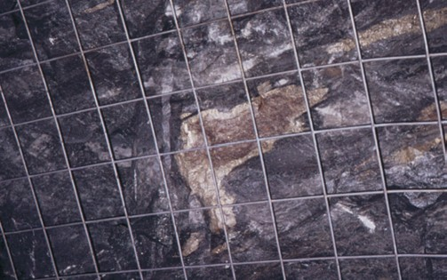
C
D

camp, or Eskay Creek, British Columbia, footwall alteration can be volumetrically extensive and many times the diame- ter of the massive sulphide lens (Galley et al., 1993). The morphology of proximal alteration zones can vary widely, but generally they tend to widen in proximity to the paleo- seafloor surface, suggesting more intensive interaction between shallowly circulating, or connate, seawater and an ascending hydrothermal fluid. The internal mineralogical zonation of the alteration zones is indicative of these mixing phenomena. A Fe-chlorite-quartz-sulphide±sericite± talc mineral assemblage is commonly associated with the core of stockwork vein mineralization, which becomes increasingly quartz- and sulphide-rich towards the lower contact of the massive sulphide lens. In some cases, talc and/or magnetite
F_{IGURE} 19. (A) Example of a zoned sulphide chimney from the Endeavour Ridge vent field (I.R. Jonasson). (B) Typical textures from a massive sulphide mound, Main vent field, Juan de Fuca Ridge. Mineralogical banding is due to incremental chimney growth, with ovoids representing worm casts. Fragment cemented by later sulphide growth during mound collapse and subsequent invasion by hydrothermal fluid. (C) Clastic sandy sulphide ore from Cretaceous Aarja deposit, Semail ophiolite, Oman. This common texture is created by repeated mound collapse resulting from anhydrite dissolution and recementing with later sulphide (photo by I.R. Jonasson). (D) Pyrite-sphalerite clast as part of a proximal debris flow, Louvicourt, Val d’Or. 15 cm metal grid for scale.

In shallow-water environments (i.e. <1,500 m water depth), boiling may have occurred either in the upflow zone or in the immediate subseafloor. Depending on the extent of boiling, this can result in vertically extensive pyritic stock-

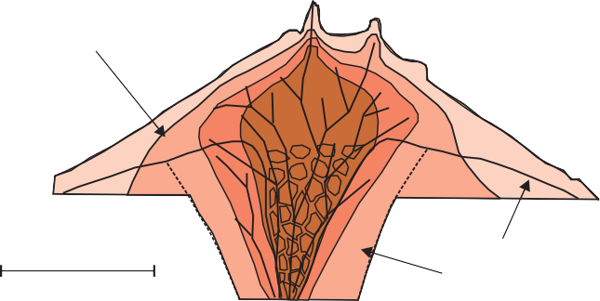
Massive sulphide mound

occur at the base of the massive sulphide lens and the top of the alteration pipe, as at several of the Matagami district VMS deposits, the Ansil deposit in the Noranda camp, and the Late Triassic Chu Chua deposit in the Slide Mountain terrane of British Columbia. The core zone is cloaked in a wider zone of Fe-Mg-chlorite-sericite, including phengite in the part of this zone that encompasses the immediate hang- ing wall to the massive sulphide lens. Outboard from this is a zone rich in sericite, phengite, Mg-chlorite, ±albite, ±car-
100 metres

Po Cp
Sp
Gn

Py Ba
Former seafloor Alteration pipe

bonate, and ±barite. This outer zone may also encompass a
portion of the hanging-wall strata above, and lateral to, the massive sulphide lens.
F_{IGURE} 20. Mineral zonation commonly observed within VMS deposits;
this zoning is largely a function of hydrothermal fluid temperature and com- position. Temperature gradient results in the zoning of sulphide minerals within both the discordant stockwork zone and the conformable sulphide mound. From Lydon (1984).

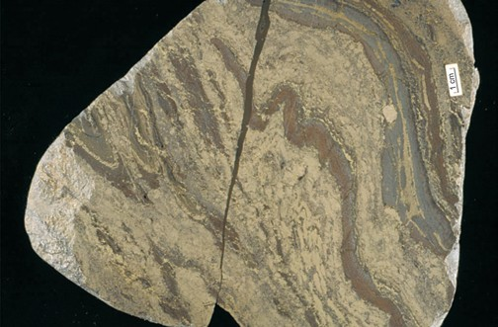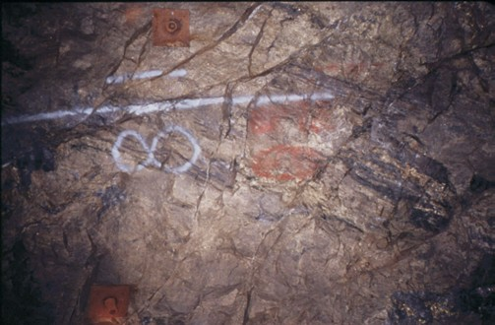
A
B
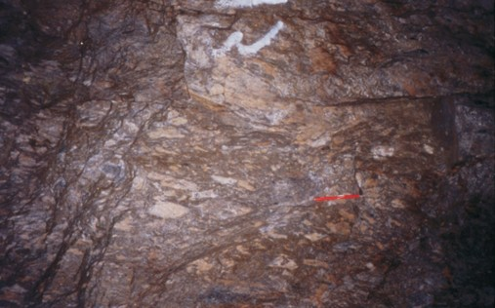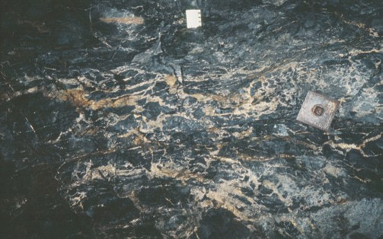
C
D

work zones, possibly with widespread and intense sericite- quartz-pyrite alteration. The extensive sericite-rich alteration system that underlies the Eskay Creek auriferous VMS deposit may be a product of extensive subsurface boiling of hydrothermal fluids, which resulted in the formation of low- temperature (<200°C) Sb-Hg-As-Pb sulphosalt-rich ore lenses (Sherlock et al., 1999). More advanced argillic alter- ation may be produced by acidic magmatic volatiles, and this alteration can lead to distinctive aluminosilicate-rich mineral assemblages when metamorphosed to greenschist grade. In the case of the LaRonde deposit, Quebec, “classic” mound- type Zn-Cu-Au massive sulphide lenses are associated with extensive zones of metamorphosed argillic alteration con- taining pyrite-chalcopyrite-bornite-gold stockwork systems. This may be the result of shallow subsurface boiling and sep- aration of a volatile-rich fluid or focused input of oxidized magmatic fluids (Dubé et al., 2004).
F_{IGURE} 21. (A) Finely bedded tuff partially replaced by massive pyrrhotite-chalcopyrite at the Ansil deposit, Noranda. 15 cm metal plates for scale.
- Cranston tuff unit with lit-par-lit replacement and in-filling by firstly by pyrite-sphalerite, followed by pyrrhotite-chalcopyrite, Ansil deposit, Noranda.
- Rhyolite clasts cemented by pyrite-sphalerite rich sulphide groundmass, Louvicourt deposit, Val d’Or. 12 cm red magnet for scale. (D) Well developed pyrrhotite-chalcopyrite vein stockwork zone with intense chlorite alteration of the rhyolite wallrocks, Ansil deposit, Noranda.
In less extreme cases, distal, low-temperature hydrother- mal alteration assemblages associated with VMS deposits may be difficult to distinguish from regional greenschist- facies metamorphic mineral assemblages. When both proxi- mal and regional semiconformable alteration zones are affected by amphibolite-grade regional or contact metamor- phism, the originally strongly hydrated alteration mineral assemblages change into a coarse-grained quartz-phyllosili- cate-aluminosilicate assemblages that are very distinct from the surrounding unaltered strata (Fig. 23). It then becomes
possible to use the systematic variations in these coarse- grained metamorphic mineral assemblages as vectors towards the core of the proximal alteration system or upsec- tion towards the paleo-seafloor (Hodges and Manojlovic, 1993).

Genetic/Exploration Models
Exploration models for VMS systems have several com- mon themes despite the large variety of submarine environ- ments in which the deposits can form. The generation of a VMS-hosting volcanic complex is a response to focused heat flow caused by tectonic extension, mantle depressurization, and the resultant formation of high-temperature mantle melts, crustal partial melts, and common bimodal volcanic succession. The large majority of VMS deposits in Canada form in either bimodal mafic or bimodal felsic volcanic ter- ranes dominated by basalt-basaltic andesite and rhyolite-rhy- odacite. Prospective VMS-hosting arc terranes are character- ized by bimodal volcanic successions that have a tholeiitic to transitional tholeiitic-calc alkaline composition. The felsic volcanics are characterized by low Zr/Y (<7) and low (La/Yb)N (<6) ratios, with elevated high field strength ele- ment contents (Zr >200 ppm, Y >30 ppm, and elevated LREE and HREE) typical of high-temperature, reduced magmas derived from partially hydrated crust (Barrie et al., 1993; Barrie, 1995; Lentz, 1998). The lower viscosities of the high-temperature felsic magmas result in rapid ascent

Zone 2 Fe-chlorite±
sericite (sulphide stringer zone)
Felsic Pyroclastics (Nepisiguit Falls Fm.)
Zone 4
Zone 3 (Phengite+
Mg-chlorite)
Zone 1 (Quartz+ Fe-chlorite)
(Fe-Mg-chlorite+ sericite)
Sulphide Zone
Zone 3
Zone 3 (Phengite+ chlorite)
3-5 km

1-3 km
3-5 km
Felsic Volcanics (Flat Landing Brook Fm.)

F_{IGURE} 22. A schematic composite section through a VMS alteration sys- tem in the Bathurst mining camp as an example of a VMS proximal alter- ation zone metamorphosed to greenschist-grade mineral assemblages. From Goodfellow et al. (2003).
with minimal heat loss into subseafloor settings where hydrothermal convection can be initiated. For this reason, most prospective VMS environments are characterized by high-level sill-dyke swarms, discrete felsic extrusive centres, and large (>15 km long and 2000 m thick) subvolcanic com- posite intrusions. The absence of substantial subvolcanic intrusions in some camps may be due to poor preservation as a result of folding and faulting.
The interaction of large volumes of volcanic strata with seawater within these high-heat extensional environments results in the formation of district-scale alteration zones that extend over the strike length of the VMS-hosting extensional feature (spreading ridge, rift, or caldera). Stacked alteration zones can have an aggregate thickness of 2000 to 3000 m, and may be intruded by resurgent phases of the underlying subvolcanic intrusion. Subvolcanic intrusions themselves can display textural features indicating high-level devolatilization and high-temperature magmatic hydrother- mal alteration (quartz-epidote-magnetite-ferroactinolite-sul- phides). In some cases, this devolatilization may contribute metals to the overlying convective hydrothermal system (Large et al., 1996; Lydon, 1996; Galley, 2003, and refer- ences therein). Regional semiconformable alteration systems resemble regional metamorphic zones (zeolite, greenschist, amphibolite), with increasing grade towards the heat source. Most Canadian VMS districts have been affected by regional metamorphism, which has resulted in recrystallization of the original alteration minerals to greenschist and/or amphibo- lite assemblages. In camps such as Noranda, Bousquet, Sturgeon Lake, Manitouwadge, Snow Lake, Leaf Rapids, and the western Stikine (Tulsequah Chief), regional meta- morphism or local contact metamorphism of alteration min- erals has produced distinctive coarse-grained mineral assem- blages characterized by such minerals as phlogopite, cordierite, anthophyllite, muscovite, staurolite, garnet, andalusite, and kyanite. The metamorphosed alteration can
activity. Precambrian VMS-related exhalites are commonly composed of finely bedded, sulphide-rich tuffaceous mate- rial. More extensive Algoma-type oxide facies Fe-forma- tions are also common in VMS-prospective back-arc envi- ronments of all ages. Both types of exhalite may form prox- imal to massive sulphide deposits or extend for strike lengths of several kilometres to tens of kilometres (Spry et al., 2000; Peter, 2003). Proximity to a hydrothermal source in these formations is indicated by positive inter-element correlation between hydrothermal components (Eu, Fe, Mn, Pb, Zn, Cd, Au, Ca, Sr, Ba, P, and CO2) versus clastic components (Si, Ti, Al, Mg, K, and Zr), increasing chondrite normalized EuEu* (hydrothermal input), and decreasing Ce/Ce* (sea- water input) towards the source (Peter and Goodfellow, 1996; Peter, 2003). Vertical and horizontal facies vary from oxide through silicate to carbonate, which in some cases, also may reflect proximity to focused hydrothermal activity (Peter, 2003).
Key Exploration Criteria
The following are the major exploration criteria for Canadian VMS deposits and key attributes of VMS-hosting volcanic complexes.
The deposits occur in volcanic belts from Late Archean to Eocene in which extension is indicated by relatively primi- tive (tholeiitic to transitional) bimodal volcanism in nascent- arc, rifted-arc, and back-arc environments. Some obducted seafloor-spreading centres and rifted continental margins are also prospective.
VMS formation occurs during periods of major ocean- closing and terrane accretion. These include the Late Archean (2.8-2.69 Ga), Paleoproterozoic (1.92-1.87 Ga), Cambro-Ordovician (500-450 Ma), Devono-Mississippian (370-340 Ma), and Early Jurassic (200-180 Ma).
In effusive flow-dominated settings in oceanic arc and continental margin arcs, VMS deposits can be associated with 15 to 25 km long, mafic to composite synvolcanic intru- sions. These intrusions are Na-rich and depleted in low field strength elements and have low airborne radiometric responses but commonly show magnetic halos due to sur- rounding zones of high-temperature fluid interaction. Exploration should be focused up to 3000 m upsection in the comagmatic volcanic suites in the hanging wall of the intru- sions. Rhyolites with high Zr (>300 ppm), negative chon- drite-normalized Eu anomalies, (La/Yb)N values of less than 7, (Gd/Yb)N values of less than 2, and Y/Zr ratios of less
Massive sulphide lens Chisel Rhyolite

LEGEND
Alteration Facies

be distinguished from essentially isochemical regional meta- morphic mineral assemblages by the losses and gains of var- ious elements during fluid-rock interactions (Fig. 15).
Footwall Dacite Chlorite-Staurolite
Biotite-Garnet Siliceous Stringer Sericite-Kyanite Amphibolite Stringer
50 m

50 m

Submarine volcanic stratigraphy that is prospective for VMS mineralization commonly contains ferruginous exhala- tive horizons as an indication of subseafloor hydrothermal
F_{IGURE} 23. A stylized cross-section through the proximal alteration zone at
the Chisel deposit, Snow Lake mining camp, illustrating the changes in mineral assemblages that occur when the terrane undergoes lower to mid- dle amphibolite-grade regional metamorphism. From Galley et al. (1993).

than 7 define high-temperature (>900°C) felsic volcanic environments favourable for VMS formation. The presence of synvolcanic dyke swarms and exhalite horizons are indicative of areas of high paleo-heat flow.
In continental back-arc, bimodal siliciclastic-dominated settings aeromagnetic surveys can be used to identify aeri- ally extensive iron formations to target hydrothermally active paleo-seafloor horizons. Variations in the mineralogy of the iron formations and varying element ratios can serve as vectors toward high-temperature hydrothermal centres. Volumetrically minor sill-dyke complexes also may identify higher temperature hydrothermal centres.
In upper greenschist-amphibolite metamorphic terranes, distinctive, coarse-grained mineral suites commonly define VMS alteration zones. These include chloritoid, garnet, stau- rolite, kyanite, andalusite, phlogopite, and gahnite. More aluminous mineral assemblages commonly occur closer to a high-temperature alteration pipe. Metamorphic mineral chemistry, such as Fe/Zn ratio of staurolite, is also a vector to ore. These largely refractory minerals have a high survival rate in surficial sediments, and can be used through heavy mineral separation as further exploration guides in till-cov- ered areas.
Mineralogy and chemistry can be used to identify large- scale hydrothermal alteration systems in which clusters of VMS deposits may form. Broad zones of semiconformable alteration will show increases in Ca-Si (epidotization-silici- fication), Ca-Si-Fe (actinolite-clinozoisite-magnetite), Na (spilitization), or K-Mg (mixed chlorite-sericite±K- feldspar). Proximal alteration associated with discordant sul- phide-silicate stockwork vein systems includes chlorite- quartz-sulphide- or sericite-quartz-pyrite±aluminosilicate- rich assemblages and is typically strongly depleted in Na and Ca due to high-temperature feldspar destruction. In addition to geochemical analysis, X-ray diffraction, PIMA, and oxy- gen isotope analysis can assist in vectoring towards higher temperature, proximal alteration zones and associated VMS mineralization. Although PIMA has been used most effec- tively on alteration systems that contain minerals with a high reflective index, there has been some success in identifying greenschist-facies minerals within Precambrian VMS hydrothermal systems (Thompson et al., 1999)

Knowledge Gaps
Researchers have gathered an impressive amount of knowledge over the last ten years with respect to how, and where, VMS deposits form within various geodynamic regimes. This is due to a combination of studies of modern seafloor environments and detailed and regional-scale stud- ies of ancient VMS environments. These studies have allowed us to place VMS depositional environments within the context of diverse supra-subduction settings that can be identified in deformed and metamorphosed terranes through lithostratigraphic facies evaluation and lithogeochemical analyses. Prospective settings for subseafloor hydrothermal systems can now be determined through identification of synvolcanic intrusions that trigger the systems, geochemical variations in altered rocks and chemical sedimentary hori- zons, and the use of mineralogy, geochemistry, and isotope geology. The fundamental ingredient for the efficient use of
these tools is an appropriate level of understanding of the architecture of the volcanic terranes. Mapping at 1:20 thou- sand scale and complementary geochronological studies of the Flin Flon, Snow Lake, Leaf Rapids, and Bathurst mining camps were key to understanding the evolution of the vari- ous VMS-hosting arc assemblages and at what period of time in this evolution the deposits formed. Detailed lithos- tratigraphic mapping was essential in unraveling deforma- tion histories and understanding the structural repetitions of prospective ore horizons. At larger scales, we still need a bet- ter understanding of the longevity of hydrothermal systems and the character and scale of fluid flow into both volcanic and sedimentary hanging-wall strata. We also need a better understanding of how to prospect for VMS environments through thick drift cover using novel heavy mineral analysis and selective leach methods. Successful exploration under cover requires improved understanding of the processes of secondary and tertiary remobilization of metals and trace elements from a VMS deposit and its associated alteration system.

Some Areas of High Mineral Potential in Canada
The recognition of new classes of high-sulphidation and shallow-water VMS deposits and their genetic association with differentiated magmatic suites in both calc-alkaline and alkaline volcanic arcs opens up new terranes and volcanic environments to exploration that were previously considered non-prospective for VMS. These environments include arc fronts and successor magmatic arcs in addition to primitive rifted-arc and back-arc terranes. Calc-alkaline to alkaline ter- ranes, such as the Triassic Nicola Group and the Lower Jurassic Hazelton Group in British Columbia, should be revisited for atypical VMS deposits. Evolved parts of Archean greenstone terranes, in particular >2.8 Ga terranes in which there was involvement of early sialic crust, should also be considered in this context, e.g. Frotet-Troilus Domain, Grand Nord, North Caribou, and western Slave subprovinces.
Incipient rift environments of the Paleoproterozoic Trans- Hudson Orogen: The presence of large volumes of iron for- mation and associated VMS mineralization in the Labrador Trough is evidence of extensive hydrothermal systems gen- erated in these 2.1 to 2.0 Ga rift systems on both margins of the orogen. Why did these not develop large VMS deposits as in other Fe-formation-rich environments (e.g. Manitouwadge)?
Intrusions associated with Ni-Cu-PGE mineralization rep- resent large volumes of magma, commonly emplaced at shallow crustal levels as part of volcano-plutonic complexes. If emplaced in a subaqueous environment, these terranes should be highly prospective for mafic siliciclastic or mafic- dominated VMS deposits. These may include the submarine volcanic stratigraphy above the Fox River and Bird River sills in Manitoba and possibly the Bad Vermilion anorthositic complex in southwestern Ontario.
Intra-continental back-arc environments have been recog- nized as highly prospective for VMS deposits. Where are the continental back-arc environments in the Superior, Slave, and Grenville provinces? Have we explored enough in the
>2.8 or <1.5 Ga terranes?

Terranes affected by thin-skinned fold-thrust tectonics present special challenges for exploration but are also highly prospective for VMS deposits. The potential for new explo- ration targets in areas such as the Central Volcanic Belt of Newfoundland is high, and the lessons learned in the Iberian Pyrite Belt with respect to exploring in such terranes can be applied in these and other similar terranes in Canada.
The so-called oceanic terranes of British Columbia, such as the Triassic Slide Mountain and Cache Creek terrane, should be re-evaluated for their VMS potential in light of the possibility that they represent back-arc and not ocean-basin environments. The presence of boninite and subvolcanic tonalite-trondhjemite intrusions ± rhyolites in these terranes would be key indicators of possible arc-back-arc systems. Boninite, in particular, is an indication of a depleted mantle source typical of nascent to back-arc regimes (Crawford et al., 1989; Stern et al., 1995; Kerrich at al., 1998; Piercey et al., 2001).

Acknowledgements
The authors would like to thank many of our colleagues whose ideas and discussions helped summarize the charac- teristics of this fascinating deposit type. They include Jim Franklin, Wayne Goodfellow, Steve Piercey, Jan Peter, Benoit Dubé, and Harold Gibson. Jan Peter, and Steve Piercey are thanked for their insightful reviews of the manu- script.

References
Aggarwal, P.K., and Longstaffe, F.J., 1987, Oxygen isotope geochemistry of metamorphosed massive sulfide deposits of the Flin Flon-Snow Lake Belt, Manitoba: Contributions to Mineralogy and Petrology, v. 96, p. 314-325.
Allen, R.L., Lundström, I., Ripa, M., Simeonov, A., Christofferson, H., 1996a, Facies analysis of a 1.9 Ga, continental margin, back arc, felsic caldera province with diverse Zn-Pb-Ag (Cu-Au) sulfide and Fe oxide deposits, Bergslagen region, Sweden: Economic Geology, v. 91, p. 979- 1008.
Allen, R. L., Weihed, P., and Svesen, S-A, 1996b, Setting of Zn-Cu-Au-Ag massive sulfide deposits in the evolution and facies architecture of a 1.9 Ga marine volcanic arc, Skellefte district, Sweden: Economic Geology, v. 91, p. 1022-1053.
Allen, R.L., Weihed, P., and Global VMS Research Project Team, 2002, Global comparisons of volcanic-associated massive sulphide districts, in Blundell, D.J., Neubauer, F., and Von Quadt, A., eds., The Timing and Location of Major Ore Deposits in an Evolving Orogen: Geological Society of London Special Publication 204, p. 13-37.
Alt, J.C., 1995, Subseafloor processes in mid-ocean ridge hydrothermal sys- tems, in Humphris, S., ed., Seafloor Hydrothermal Systems: Physical, Chemical, Biological, and Geological Interactions: American Geophysical Union Monograph 91, p. 85-114.
Bailes, A.H., and Galley, A.G., 1999, Evolution of the Paleoproterozoic Snow Lake arc assemblage and geodynamic setting for associated vol- canic-hosted massive sulfide deposits, Flin Flon Belt, Manitoba, Canada: Canadian Journal of Earth Science, v. 36, p. 1789-1805.
Barrett, T.J., and Sherlock, R.L, 1996a, Volcanic stratigraphy, lithogeo- chemistry, and seafloor setting of the H-W massive sulfide deposit, Myra Falls, Vancouver Island, British Columbia: Exploration and Mining Geology, v. 5, p. 421-458.
——— 1996b, Geology, lithogeochemistry, and volcanic setting of the Eskay Creek Au-Ag-Cu-Zn deposit, northern British Columbia: Exploration and Mining Geology, v. 5, p.339-368.
Barrie, C.T., 1995, Zircon thermometry of high-temperature rhyolites near volcanic-associated sulfide deposits: Geology, v. 23, p. 169-172.
Barrie, C.T., and Hannington, M.D., 1999, Introduction: Classification of VMS deposits based on host rock composition, in Barrie, C.T., and Hannington, M.D., eds., Volcanic-Associated Massive Sulfide

Deposits: Processes and Examples in Modern and Ancient Settings: Reviews in Economic Geology, v. 8, p. 2-10.
Barrie, C.T., Ludden, J.N., and Green, A.H., 1993, Geochemistry of vol- canic rocks associated with Cu-Zn and Ni-Cu deposits in the Abitibi Subprovince: Economic Geology, v. 88, p. 1341-1358.
Bédard, J.H., and Hébert, R., 1996, The lower crust of the Bay of Islands ophiolite, Canada: Petrology, mineralogy, and the importance of syn- texis in magmatic differentiation in ophiolites and at ocean ridges: Journal of Geophysical Research, v. 101, p. 25105-25124.
Bédard, J.H., Lauzière, K., Tremblay, A., and Sangster, A., 1998, Evidence from Betts Cove ophiolite boninites for forearc seafloor-spreading: Tectonophysics, v. 284, p. 233-245.
Bloomer, S.H., Taylor, B., MacLeod, C.J., Stern, R.J., Fryer, P., Hawkins J.W., Johnson, L., 1995, Early arc volcanism and the ophiolite problem: A perspective from drilling in the Western Pacific: Geophysical Monograph 88, p. 1-30.
Bradshaw, G.D., Rowins, S.M., Peter, J.M., and Taylor, B.E., 2003, Genesis of the Wolverine deposit, Finlayson Lake district, Yukon: A transitional style of polymetallic massive sulfide mineralization in an ancient con- tinental margin setting: The Gangue, p. 1-7.
Brauhart, C.W., Groves, D.I., and Morant, P., 1998, Regional alteration sys- tems associated with volcanogenic massive sulfide mineralization at Panorama, Pilbara, Western Australia: Economic Geology, v. 93, p. 292-302.
Carvalho, D., Barriga, F.J.A.S., and Munha, J., 1999, Bimodal-siliciclastic systems - The case of the Iberian Pyrite Belt, in Barrie, C.T., and Hannington, M.D., eds., Volcanic-Associated Massive Sulfide Deposits: Processes and Examples in Modern and Ancient Settings: Reviews in Economic Geology, v. 8, p. 375-402.
Cathles, L.M., 1993, Oxygen isotope alteration in the Noranda Mining District, Abitibi Greenstone Belt, Quebec: Economic Geology, v. 88, p. 1483-1511.
Corbett, K.D., 1992, Stratigraphic-volcanic setting of massive sulfide deposits in the Cambrian Mount Read volcanics, western Tasmania: Economic Geology, v. 87, p. 564-586.
Crawford, A.J., Falloon, T.J., and Green D.H., 1989, Classification, petro- genesis and tectonic setting of boninite, in Crawford, A.J., ed., Boninites and Related Rocks: Unwin Hyman, London, p. 2-48.
Dimroth, E., Imreh, L., Goulet, N., and Rocheleau, M., 1983, Evolution of the south-central segment of the Archean Abitibi Belt, Quebec; Part II, Tectonic evolution and geomechanical model: Canadian Journal of Earth Sciences 20, p. 1355-1373.
Doyle, M.G., and McPhie, J, 2000, Facies architecture of a silicic intrusion- dominated volcanic centre at Highway-Reward, Queensland, Australia: Journal of Volcanology and Geothermal Research, v. 99, p. 79-96.
Dubé, B., Mercier-Langevin, P., Hannington, M.D., Davis, D.W., and LaFrance, B., 2004, Le gisement de sulfures massifs volcanogènes aurifères LaRonde, Abitibi, Québec: alteration, mineralisation genèse et implications pour l’exploration: Ministère de Resources Naturelles, Québec, Open File Report MB 2004-03, 112 p.
Eastoe, C.J., Solomon, M., and Walshe, J.L., 1987, District-scale alteration associated with massive sulfide deposits in the Mount Read volcanics, Tasmania: Economic Geology, v. 82, p. 1204-1238.
Eckstrand, O.R., Sinclair, W.D., and Thorpe, R.I., eds. 1995, Geology of Canadian Mineral Deposit Types, Geology of Canada, No. 8, Decade of North American Geology (DNAG): Geological Society of America, Part 1, p. 183-196.
Eldridge, C. W., Barton, P.B., and Ohmoto, H., 1983, Mineral textures and their bearing on formation of the Kuroko orebodies: Economic Geology Monograph, v. 5, p. 241-281.
Epp, M., and Crocket, J.H., 1999, Geology and geochemistry of the Potterdoal Cu-Zn deposit, Munro township, Ontario, in Hannington, M.D., and Barrie, C.T., eds., The Giant Kidd Creek Volcanogenic Massive Sulfide Deposit, Western Abitibi Subprovince, Canada: Economic Geology Monograph 10, p. 593-612.
Franklin, J.M., 1996, Volcanic-associated massive sulphide base metals, in Eckstrand, O.R., Sinclair, W.D., and Thorpe, R.I., eds., Geology of Canadian Mineral Deposit Types: Geological Survey of Canada, Geology of Canada, no. 8, p. 158-183.
Franklin, J.M., and Hannington, M.D., 2002, Volcanogenic massive sulfides through time: Geological Society of America, 2002 Annual Meeting, Abstracts with Programs, v. 34, p. 283.

Franklin, J.M., Lydon, J.W., and Sangster, D.F., 1981, Volcanic-associated massive sulfide deposits; in Skinner, B.J., ed., Economic Geology 75th Anniversary Volume: Society of Economic Geologists, p. 485-627.
Franklin, J.M., Hannington, M.D., Jonasson, I.R., and Barrie, C.T., 1998, Arc-related volcanogenic massive sulphide deposits: Proceedings of Short Course on Metallogeny of Volcanic Arcs, January 24-25, Vancouver: British Columbia Geological Survey Open-File 1998-8, p. N1-N32.
Franklin, J.M., Gibson, H.L., Jonasson, I.R., and Galley, A.G., 2005, Volcanogenic Massive Sulfide Deposits, in Hedenquist, J.W., Thompson, J.F.H., Goldfarb, R.J., and Richards, J.P., eds., Economic Geology 100th Anniversary Volume: The Economic Geology Publishing Company, p. 523-560.
Galley, A.G., 1993, Semi-conformable alteration zones in volcanogenic massive sulphide districts: Journal of Geochemical Exploration, v. 48, p. 175-200.
——— 2003, Composite synvolcanic intrusions associated with Precambrian VMS- related hydrothermal systems: Mineralium Deposita, v. 38, p. 443-473.
Galley, A.G., and Jonasson, I.R., 2003, Classification and tectonic environ- ments of VMS deposits in the Flin Flon mining camp, Manitoba: Geological Association of Canada/Mineralogical Association of Canada Annual General Meeting, Program with Abstracts (CD-ROM).
Galley, A.G., and Koski, R.A., 1999, Setting and characteristics of ophiolite- hosted volcanogenic massive sulfide deposits, in Barrie, C.T., and Hannington, M.D., eds., Volcanic-Associated Massive Sulfide Deposits: Processes and Examples in Modern and Ancient Settings: Reviews in Economic Geology, v. 8, p. 215-236.
Galley, A.G., Bailes, A.H., and Kitzler, G., 1993, Geological setting and hydrothermal evolution of the Chisel Lake and North Chisel Zn-Pb-Ag- Au massive sulphide deposit, Snow Lake, Manitoba: Exploration and Mining Geology, v. 2, p. 271-295.
Gibson, H.L., and Watkinson, D.H., 1990, Volcanogenic massive sulphide deposits of the Noranda Cauldron and Shield Volcano, Quebec, in Rive, M., Verpaelst, P., Gagnon, Y., Lulin, J.M., Riverin, G., and Simard, A., eds., The Northwestern Quebec Polymetallic Belt: Canadian Institute for Mining and Metallurgy, Special Volume 43, p. 119-132.
Goodfellow, W.D., Zierenberg, R.A., and ODP 196 Shipboards Science Party, 1999, Genesis of massive sulfide deposits at sediment-covered spreading centers, in Barrie, C.T., and Hannington, M.D., eds., Volcanic-Associated Massive Sulfide Deposits: Processes and Examples in Modern and Ancient Settings: Reviews in Economic Geology, v. 8, Society of Economic Geologists, p. 297-324.
Goodfellow, W.D., McCutcheon, S.R., and Peter, J.M., 2003, Massive sul- fide deposits of the Bathurst Mining Camp, New Brunswick and Northern Maine: Introduction and summary of findings, in Goodfellow, W.D., McCutcheon, S.R., and Peter, J.M., eds., Massive Sulfide Deposits of the Bathurst Mining Camp, New Brunswick, and northern Maine: Economic Geology Monograph 11, Society of Economic Geologists, p. 1-16.
Green, G.R., Ohmoto, H., Date, J., and Takahashi, T., 1983, Whole-rock oxygen isotope distribution in the Fukazawa-Kosaka area, Hokuroko district, Japan, and its potential application to mineral exploration, in Ohnoto, H., and Skinner, B.J., ed., The Kuroko and Related Volcanogenic Massive Sulfide Deposits: Economic Geology Monograph 5, Society of Economic Geologists, p. 395-511.
Groves, D.I., Goldfarb, R.J., Gebre-Mariam, H., Hagemann, S.G., and Robert, F., 1998, Orogenic gold deposits - a proposed classification in the context of their crustal distribution and relationship to other gold deposit types: Ore Geology Reviews, v. 13, p. 7-27.
Hamilton, W.B., 1995, Subduction systems and magmatism: Geological Society of London Special Publication, v. 81, p. 3-28.
Hannington, M.D., Jonasson, I.R., Herzig, P.M., and Petersen, S., 1995, Physical and chemical processes of seafloor mineralization at mid- ocean ridges, in Humphris, S., ed., Seafloor Hydrothermal Systems: Physical, Chemical, Biological, and Geological Interactions: American Geophysical Union, Geophysical Monograph v. 91, p. 115-157.
Hannington, M.D., Galley, A.G., Herzig, P.M., and Petersen, S., 1998, Comparison of the TAG mound and stockwork complex with Cyprus- type massive sulfide deposits; Proceedings of the Ocean Drilling Program, Scientific Results Volume 158, College Station, TX, p. 389- 415.
Hannington, M.D., Barrie, C.T., and Bleeker, W., 1999a, The giant Kidd Creek volcanogenic massive sulfide deposit, western Abitibi

Subprovince, Canada, in Hannington, M.D., and Barrie, C.T., eds., The Giant Kidd Creek Volcanogenic Massive Sulfide Deposit, Western Abitibi Subprovince, Canada: Economic Geology Monograph 10, p. 1-30.
Hannington, M.D., Bleeker, W., and Kjarsgaard, I., 1999b, Sulfide mineral- ogy, geochemistry and ore genesis of the Kidd Creek deposit: Part II. The bornite zone, in Hannington, M.D., and Barrie, C.T., eds., The Giant Kidd Creek Volcanogenic Massive Sulfide Deposit, Western Abitibi Subprovince, Canada: Economic Geology Monograph 10, p. 225-266.
Hannington, M.D., Poulsen, K.H., Thompson, J.F.H., and Sillitoe, R.H., 1999c, Volcanogenic gold in the massive sulfide environment, in Barrie, C.T., and Hannington, M.D., eds., Volcanic-Associated Massive Sulfide Deposits: Processes and Examples in Modern and Ancient Settings: Reviews in Economic Geology 8, p. 325-356.
Hannington, M.D., Santaguida, F., Kjarsgaard, I.M., and Cathles, L.M., 2003, Regional greenschist facies hydrothermal alteration in the central Blake River Group, western Abitibi subprovince, Canada: Mineralium Deposita, v. 38, p. 393-422.
Herrington, R.J., Armstrong, R.N., Zaykov, V.V., Maslennikov, V.V., Tessalina, S.G., Orgeval, J.J., and Taylor, R.N.A., 2002, Massive sulfide deposits in the South Urals; geological setting within the framework of the Uralide Orogen, in Brown, D., Juhlin, C., and Puchkov, V., eds., Mountain Building in the Uralides; Pangea to the Present: Geophysical Monograph. 132, p. 155-182.
Herzig, P.M., and Hannington, M.D., 1995, Polymetallic massive sulfides at the modern seafloor: A review: Ore Geology Reviews, v. 10, p. 95-115. Hodges, D.J., and Manojlovic, P.M., 1993, Application of lithogeochemistry
to exploration for deep VMS deposits in high grade metamorphic rocks: Journal of Geochemical Exploration, v. 48, p. 201-224.
Kalogeropoulos, S.I., and Scott, S.D., 1983, Mineralogy and geochemistry of tuffaceous exhalites (Tetsusekiei) of the Fukazawa mine, Hokuroko District, Japan: in Ohnoto, H., and Skinner, B.J., eds., The Kuroko and Related Volcanogenic Massive Sulfide Deposits: Economic Geology Monograph 5, p. 412-432.
Kalogeropoulos, S.I., and Scott, S.D., 1989, Mineralogy and geochemistry of an Archean tuffaceous exhalite: the Main Contact Tuff, Millenbach mine area, Noranda, Quebec: Canadian Journal of Earth Sciences, v. 26, p. 88-105.
Kerr, D.J., and Gibson, H.L., 1993, A comparison between the volcanology and geochemistry of volcanic successions hosting the Horne mine deposit and smaller intra-cauldron deposits of the mine sequence: Economic Geology, v. 88, p. 1419-1443.
Kerrich, R., Wyman, D., Fan, J., and Bleeker, W., 1998, Boninite series - low Ti-tholeiite associations from the 2.7 Ga Abitibi greenstone belt: Earth and Planetary Science Letters, v. 164, p. 303-316.
Lagerblad, B., and Gorbatschev, R., 1985, Hydrothermal alteration as a con- trol of regional geochemistry and ore formation in the central Baltic Shield: Geologische Rundschau, v. 74, p. 33-49.
Large, R.R., 1992, Australian volcanic-hosted massive sulphide deposits: features, styles and genetic models: Economic Geology, v. 87, p. 471-510. Large, R.R., Doyle, M., Raymond, O., Cooke, D., Jones, A., and Heaman,
L., 1996, Evaluation of the role of Cambrian granites in the genesis of world class VHMS deposits in Tasmania: Ore Geology Reviews, v. 10, p. 215-230.
Lentz, D.R., 1998, Petrogenetic evolution of felsic volcanic sequences asso- ciated with Phanerozoic volcanic-hosted massive sulfide systems: the role of extensional geodynamics: Ore Geology Reviews, v. 12, p. 289- 327.
Liaghat, S., and MacLean, W.H., 1992, The Key Tuffite, Matagami mining district: Origin of the tuff components and mass changes: Exploration and Mining Geology, v. 1, p. 197-207.
Lydon, J.W., 1984. Some observations on the morphology and ore textures of volcanogenic sulfide deposits of Cyprus: Geological Survey of Canada, Current Research, Paper 84-01A, p. 601-610.
——— 1996, Characteristics of volcanogenic massive sulfide deposits: Interpretations in terms of hydrothermal convection systems and mag- matic hydrothermal systems: Instituto Tecnologico Geominero de Espana, Boletin geologico y minero, v. 107, p. 15-64.
Morton, J.L., and Franklin, J.M., 1987, Two-fold classification of Archean volcanic-associated massive sulfide deposits: Economic Geology, v. 82, p. 1057-1063.
Morton, R.L., Hudak, G.J., Walker, J.S., and Franklin, J.M., 1990, Physical volcanology and hydrothermal alteration of the Sturgeon Lake caldera

complex, in J.M. Franklin, Schneiders, B.R., and Koopman, E.R., eds., Mineral Deposits in the Western Superior Province, Ontario: Open File 2164, Geological Survey of Canada, p. 74-94.
Munha, J., and Kerrich, R., 1980, Sea water-basalt interaction in spilites from the Iberian Pyrite Belt: Contributions to Mineralogy and Petrology, v. 73, p. 191-200.
Nelson, J., and Mihalynuk, M., 2004, Mega-terranes and deep structures: tectonics and the potential for major new mineral deposits in British Columbia: Mineral Exploration Roundup, Program with Abstracts, p. 26.
Paradis, S., Taylor, B.E., Watkinson, D.H., and Jonasson, I.J., 1993, Oxygen isotope zonation and alteration in the Noranda mining district, Abitibi greenstone belt, Quebec: Economic Geology, v. 88, p. 1512-1525.
Peter, J.M., 2003, Ancient iron-rich metalliferous sediments (iron forma- tions): Their genesis and use in the exploration for stratiform base metal sulphide deposits, with examples from the Bathurst Mining Camp, in Lentz, D.R., ed., Geochemistry of Sediments and Sedimentary Rocks: Evolutionary Considerations to Mineral Deposit-Forming Environments, GEOtext 4: Geological Association of Canada, p. 145-173.
Peter, J.M., and Goodfellow, W.D., 1996, Mineralogy, bulk and rare earth element geochemistry of massive sulfide-associated hydrothermal sed- iments of the Brunswick Horizon, Bathurst Mining Camp, New Brunswick: Canadian Journal of Earth Sciences, v. 33, p. 252-283.
Peter, J.M., and Scott, S.D., 1999, Windy Craggy, northwestern British Columbia: The world’s largest Besshi-type deposit, in Barrie, C.T., and Hannington, M.D., eds., Volcanic-Associated Massive Sulfide Deposits: Processes and Examples in Modern and Ancient Settings: Reviews in Economic Geology, v. 8, p. 261-295.
Petersen, S., Herzig, P.M., and Hannington, M.D., 2000, Third dimension of a presently forming VMS deposit: TAG Hydrothermal Mound, Mid- Atlantic Ridge, 26°N: Mineralium Deposita, v. 35, p. 233-259.
Petersen, S., Schwarz-Schampera, U., Herzig, P., Hannington, M., and Jonasson, I., 2004, Hydrothermal precipitates associated with bimodal volcanism in the Central Bransfield Strait, Antarctica: Mineralium Deposita, v. 39, p. 358-379.
Piercey, S.J., Murphy, D.C., Mortensen, J.K., and Paradis, S., 2001, Boninitic magmatism in a continental margin setting, Yukon-Tanana terrane, southeastern Yukon, Canada: Geology, v. 29, p. 731-734.
Poulsen, H., and Hannington, M., 1995, Auriferous Volcanogenic Sulfide Deposits, in Eckstrand, O.R., Sinclair, W.D., and Thorpe, R.I., eds. Geology of Canadian Mineral Deposit Types, Geology of Canada, no. 8, Decade of North American Geology (DNAG): Geological Society of America, Part 1. p. 183-196.
Powell, W.G., Carmichael, D.M., and Hodgeson, C.J., 1993, Relative timing of metamorphism and tectonism during the evolution of the southern Abitibi greenstone belt. in Caty, J.L., ed., L’Exceptionnel potentiel min- eral du Quebec, une realite a decouvrir; resume des conferences; semi- naire d’information 1993 (The exceptional mineral potential of Quebec, a reality yet to be discovered; information seminar 1993) Conference Abstracts. DV – Direction generale de l’Exploration Geologique et Minerale. p. 49-50.
Richards, J.P., 2003, Tectono-magmatic precursors for porphyry Cu-(Mo- Au) deposit formation: Economic Geology, v. 98, p. 1515-1534.
Sangster, D., 1980, Quantitative characteristics of volcanogenic massive sulphide deposits I. Metal content and size distribution of massive sul- phide deposits in volcanic centers: Canadian Institute of Mining and Metallurgy Bulletin, v. 73, p. 74-81.
Santaguida, F., Gibson, H.L., Watkinson, D.H., and Hannington, M.D., 1998, Semi-conformable epidote-quartz hydrothermal alteration in the Central Noranda Volcanic Complex: Relationship to volcanic activity and VMS mineralization: Canadian Minerals Research Organization Project 94E07, Annual Report, The Use of Regional-Scale Alteration and Subvolcanic Intrusions in the Exploration for Volcanic-Associated Massive Sulphide Deposits, p. 139-180.
Sebert, C., and Barrett, T.J., 1996, Stratigraphy, alteration, and mineraliza- tion at the Tulsequah chief massive sulfide deposit, northwestern British Columbia; Exploration and Mining Geology 5, 4, p. 281-308.
Sharpe, R., and Gemmell, J.B., 2002, The Archean Cu-Zn magnetite-rich Gossan Hill volcanic-hosted massive sulfide deposit, Western Australia; genesis of a multistage hydrothermal system: Economic Geology, v. 97, p. 517-539.
Sherlock, R.L., Roth, T., Spooner, E.T.C., and Bray, C.J., 1999, The origin of the Eskay Creek precious metal-rich volcanogenic massive sulfide

deposit: fluid inclusion and stable isotope data: Economic Geology, v. 94, p. 803-824.
Sillitoe, R.H., Hannington, M.D., and Thompson, J.F.H., 1996, High sulfi- dation deposits in the volcanogenic massive sulfide environment: Economic Geology, v. 91, p. 204-212.
Sinclair, W.D., Chorlton, L.B., Laramée, R.M., and Eckstrand, O.R., 1999, World Minerals Geoscience Database Project: Digital databases of gen- eralized world geology and mineral deposits for mineral exploration and research; http://gdr.nrcan.gc.ca/minres/index_e.php.
Singer, D.A., 1995, World-class base and precious metal deposits - a quan- titative analysis: Economic Geology, v. 90, p. 88-104.
Spooner, E.T.C., and Fyfe, W.S., 1973, Subseafloor metamorphism, heat and mass transfer: Contributions to Mineralogy and Petrology, v. 42, p. 287-304.
Spry, P.G., Peter, J.M., and Slack, J.F., 2000, Meta-exhalites as exploration guides to ore, in Spry, P.G., Marshall, B., and Vokes, F.M., eds., Metamorphosed and Metamorphogenic Ore Deposits: Reviews in Economic Geology, v. 11, p. 163-201.
Stern, R.A., Syme, E.C., Bailes, A.H., and Lucas, S.B., 1995, Paleoproterozoic (1.90-1.86 Ga) arc volcanism in the Flin Flon Belt, Trans-Hudson Orogen, Canada: Contributions to Mineralogy and Petrology, v. 119, p. 117-141.
Stinton, J.M., and Detrick, R.S., 1992, Mid-ocean ridge magma chambers: Journal of Geophysical Research, v. 97, p. 197-216.
Swinden, H.S., Kean, B.F., and Dunning, G.R., 1988, Geological and pale- otectonic settings of volcanogenic massive sulfide mineralization in Central Newfoundland, in Swinden, H.S., and Kean, B.F., eds., The Volcanogenic Sulphide Districts of Newfoundland: A Guidebook and Reference Manual for Volcanogenic Sulphide Deposits in the Early Paleozoic Oceanic Volcanic Terranes of Central Newfoundland: Geological Association of Canada, Mineral Deposits Division, p. 2-27.
Syme, E.C., and Bailes, A.H., 1993, Stratigraphy and tectonic setting of Early Proterozoic volcanogenic massive sulphide deposits, Flin Flon, Manitoba: Economic Geology, v. 88, p. 566-589.
Taylor, B.E., and South B.C., 1985, Regional stable isotope systematics of hydrothermal alteration and massive sulfide deposition in the West Shasta District, California: Economic Geology, v. 80, p. 2149-2163.
Thompson, A. J., Hauff, B., and Robitaille, P.L., 1999, Alteration mapping in exploration: Application of short-wave infrared (SWIR) spec- troscopy: Society of Economic Geology Newsletter, v. 39.
van Staal, C.R., Wilson, R.A., Rogers, N., Fyffe, L.R., Langton, J.P., McCutcheon, S.R., McNicoll, V., and Ravenhurst, C.E., 2003, Geology and tectonic history of the Bathurst Supergroup, Bathurst Mining Camp, and its relationships to coeval rocks in southwestern New Brunswick and adjacent Maine - a synthesis, in Goodfellow, W.D., McCutcheon, S.R., and Peter, J.M., eds., Massive Sulfide Deposits of the Bathurst Mining Camp, New Brunswick and Northern Maine: Economic Geology Monograph 11, p. 37-60.
Walker, P.N., and Barbour, D.M., 1981,Geology of the Buchans ore horizon breccias, in Swanson, E.A., Strong, D.F., and Thurlow, J.G., eds., The Buchans Ore Body; Fifty Years of Geology and Mining: Geological Association of Canada, Special Paper 22, p. 161-185.
Whalen, J.B., McNicoll, V.J., Galley, A.G., and Longstaffe, F.J., 2004, Tectonic and metallogenic importance of an Archean composite high- and low-Al tonalite suite, western Superior Province, Canada: Precambrian Research, v. 132, p. 275-301.
Wyman, D.A., Bleeker, W., and Kerrich, R., 1999, A 2.7 Ga komatiite, low Ti tholeiite, arc tholeiite transition, and inferred proto-arc geodynamic setting of the Kidd Creek deposit: Evidence from precise trace element data, in Hannington, M.D., and Barrie, C.T., eds., The Giant Kidd Creek Volcanogenic Massive Sulfide Deposit, Western Abitibi Subprovince, Canada: Economic Geology Monograph 10, p. 511-528.
Yang, K., and Scott, S.D., 2003, Geochemical relationships of felsic mag- mas to ore metals in massive sulfide deposits of the Bathurst mining camp, Iberian Pyrite Belt, Hokuroko district and the Abitibi Belt, in Goodfellow, W.D., McCutcheon, S.R., and Peter, J.M., eds., Massive Sulfide Deposits of the Bathurst Mining Camp, New Brunswick and Northern Maine: Economic Geology, Monograph 11, p. 457-478.
Ziegler, P.L., 1992, Plate tectonics, plate moving mechanisms and rifting: Tectonophysics, v. 215, p. 9-34.

